**C**

Commonly Asked C Programming Interview Questions | Set 1

**What is the difference between declaration and definition of a variable/function**  
**Ans:** Declaration of a variable/function simply declares that the variable/function exists somewhere in the program but the memory is not allocated for them. But the declaration of a variable/function serves an important role. And that is the type of the variable/function. Therefore, when a variable is declared, the program knows the data type of that variable. In case of function declaration, the program knows what are the arguments to that functions, their data types, the order of arguments and the return type of the function. So that’s all about declaration. Coming to the definition, when we define a variable/function, apart from the role of declaration, it also allocates memory for that variable/function. Therefore, we can think of definition as a super set of declaration. (or declaration as a subset of definition). From this explanation, it should be obvious that a variable/function can be declared any number of times but it can be defined only once. (Remember the basic principle that you can’t have two locations of the same variable/function).

// This is only declaration. y is not allocated memory by this statement

extern int y;

// This is both declaration and definition, memory to x is allocated by this statement.

int x;

**What are different storage class specifiers in C?**  
**Ans:** auto, register, static, extern

**What is scope of a variable? How are variables scoped in**[**C**](http://www.geeksforgeeks.org/c/)**?**  
**Ans:** Scope of a variable is the part of the program where the variable may directly be accessible. In C, all identifiers are lexically (or statically) scoped. See [this](https://www.geeksforgeeks.org/scope-rules-in-c/)for more details.

**What is the difference between Scope and Lifetime?**

**Ans:**

**What is Scope?**

***Scope*** is the region or section of code where a variable can be accessed.

**What is a lifetime?**

***Lifetime*** is the time duration where an object/variable is in a valid state.

For, ***Automatic/Local non-static variables Lifetime is limited to their Scope***.  
In other words, automatic variables are automagically destroyed once the scope({,}) in which they are created ends. Hence the name automatic to begin with.

**How will you print “Hello World” without semicolon?**  
**Ans:**

|  |
| --- |
| #include <stdio.h>  int main(void)  {      if (printf("Hello World")) {      }  } |

See [print “Geeks for Geeks” without using a semicolon for answer](https://www.geeksforgeeks.org/write-a-c-program-to-print-geeks-for-geeks-without-using-a-semicolon/).

**When should we use pointers in a C program?**  
**1.** To get address of a variable  
***2.****For achieving pass by reference in C:* Pointers allow different functions to share and modify their local variables.  
***3.****To pass large structures* so that complete copy of the structure can be avoided.  
***4.****To implement “linked” data structures*like linked lists and binary trees.

**How are variables scoped in C – Static or Dynamic?**

**Ans:** In C, variables are always [statically (or lexically) scoped](http://en.wikipedia.org/wiki/Scope_%28programming%29#Lexical_scoping) i.e., binding of a variable can be determined by program text and is independent of the run-time function call stack.

For example, output for the below program is 0, i.e., the value returned by f() is not dependent on who is calling it. f() always returns the value of global variable x.

|  |
| --- |
| # include <stdio.h>    int x = 0;  int f()  {     return x;  }  int g()  {     int x = 1;     return f();  }  int main()  {    printf("%d", g());    printf("\n");    getchar();  } |

**What is NULL pointer?**  
**Ans:** NULL is used to indicate that the pointer doesn’t point to a valid location. Ideally, we should initialize pointers as NULL if we don’t know their value at the time of declaration. Also, we should make a pointer NULL when memory pointed by it is deallocated in the middle of a program.

**What is Dangling pointer?**  
**Ans:** Dangling Pointer is a pointer that doesn’t point to a valid memory location. Dangling pointers arise when an object is deleted or deallocated, without modifying the value of the pointer, so that the pointer still points to the memory location of the deallocated memory. Following are examples.

|  |
| --- |
| // EXAMPLE 1  int* ptr = (int*)malloc(sizeof(int));  ..........................free(ptr);    // ptr is a dangling pointer now and operations like following are invalid  *ptr = 10; // or printf("%d", *ptr); |

|  |
| --- |
| // EXAMPLE 2  int* ptr = NULL  {      int x = 10;      ptr = &x;  }  // x goes out of scope and memory allocated to x is free now.  // So ptr is a dangling pointer now. |

**What is memory leak? Why it should be avoided**  
**Ans:** Memory leak occurs when programmers create a memory in heap and forget to delete it. Memory leaks are particularly serious issues for programs like daemons and servers which by definition never terminate.

|  |
| --- |
| /* Function with memory leak */  #include <stdlib.h>    void f()  {      int* ptr = (int*)malloc(sizeof(int));        /* Do some work */        return; /* Return without freeing ptr*/  } |

**What are local static variables? What is their use?**  
**Ans:**A local static variable is a variable whose lifetime doesn’t end with a function call where it is declared. It extends for the lifetime of complete program. All calls to the function share the same copy of local static variables. Static variables can be used to count the number of times a function is called. Also, static variables get the default value as 0. For example, the following program prints “0 1”

|  |
| --- |
| #include <stdio.h>  void fun()  {      // static variables get the default value as 0.      static int x;      printf("%d ", x);      x = x + 1;  }    int main()  {      fun();      fun();      return 0;  }  // Output: 0 1 |

**What are static functions? What is their use?**  
**Ans:**

In C, functions are global by default. The “*static*” keyword before a function name makes it static. For example, below function *fun()*is static.

|  |
| --- |
| static int fun(void)  {    printf("I am a static function ");  } |

Unlike global functions in C, access to static functions is restricted to the file where they are declared. Therefore, when we want to restrict access to functions, we make them static. Another reason for making functions static can be reuse of the same function name in other files.

For example, if we store following program in one file *file1.c*

|  |
| --- |
| /* Inside file1.c */  static void fun1(void)  {    puts("fun1 called");  } |

And store following program in another file *file2.c*

|  |
| --- |
| /* Iinside file2.c  */  int main(void)  {    fun1();    getchar();    return 0;  } |

Now, if we compile the above code with command “*gcc file2.c file1.c*”, we get the error *“undefined reference to `fun1’”* . This is because *fun1()* is declared *static*in *file1.c* and cannot be used in *file2.c*.

**What are main characteristics of C language?**  
C is a procedural language. The main features of C language include low-level access to memory, simple set of keywords, and clean style. These features make it suitable for system programming like operating system or compiler development.

**What is difference between i++ and ++i?**  
1) The expression ‘i++’ returns the old value and then increments i. The expression ++i increments the value and returns new value.  
2) Precedence of postfix ++ is higher than that of prefix ++.  
3) Associativity of postfix ++ is left to right and associativity of prefix ++ is right to left.  
4) In C++, ++i can be used as l-value, but i++ cannot be. In C, they both cannot be used as l-value.  
See [Difference between ++*p, *p++ and *++p](https://www.geeksforgeeks.org/difference-between-p-p-and-p/) for more details.

**What is l-value?**  
l-value or location value refers to an expression that can be used on left side of assignment operator. For example in expression “a = 3”, a is l-value and 3 is r-value.  
l-values are of two types:  
“nonmodifiable l-value” represent a l-value that can not be modified. const variables are “nonmodifiable l-value”.  
“modifiable l-value” represent a l-value that can be modified.

Refer [lvalue and rvalue in C language](https://www.geeksforgeeks.org/lvalue-and-rvalue-in-c-language/)for details.

**What is the difference between array and pointer?**  
See [Array vs Pointer](https://www.geeksforgeeks.org/difference-pointer-array-c/)

**How to write your own sizeof operator?**

|  |
| --- |
| #define my_sizeof(type) (char *)(&type+1)-(char*)(&type) |

See [Implement your own sizeof](https://www.geeksforgeeks.org/implement-your-own-sizeof/) for more details.

**How will you print numbers from 1 to 100 without using loop?**  
We can use recursion for this purpose.

|  |
| --- |
| /* Prints numbers from 1 to n */  void printNos(unsigned int n)  {    if(n > 0)    {      printNos(n-1);      printf("%d ",  n);    }  } |

**What is volatile keyword?**  
The volatile keyword is intended to prevent the compiler from applying any optimizations on objects that can change in ways that cannot be determined by the compiler.  
Objects declared as volatile are omitted from optimization because their values can be changed by code outside the scope of current code at any time. See [Understanding “volatile” qualifier in C](https://www.geeksforgeeks.org/understanding-volatile-qualifier-in-c/) for more details.

**Can a variable be both const and volatile?**  
yes, the const means that the variable cannot be assigned a new value. The value can be changed by other code or pointer. For example the following program works fine.

|  |
| --- |
| int main(void)  {      const volatile int local = 10;      int *ptr = (int*) &local;      printf("Initial value of local : %d \n", local);      *ptr = 100;      printf("Modified value of local: %d \n", local);      return 0;  } |

**C++**

Commonly Asked C++ Interview Questions | Set 1

**What are the differences between C and C++?**  
**1)** C++ is a kind of superset of C, most of C programs except few exceptions (See [this](https://www.geeksforgeeks.org/write-c-program-produce-different-result-c/)and [this](https://www.geeksforgeeks.org/write-c-program-wont-compiler-c/)) work in C++ as well.  
**2)** C is a procedural programming language, but C++ supports both procedural and Object Oriented programming.  
**3)** Since C++ supports object oriented programming, it supports features like function overloading, templates, inheritance, virtual functions, friend functions. These features are absent in C.  
**4)** C++ supports exception handling at language level, in C exception handling is done in traditional if-else style.  
**5)**C++ supports [references](https://www.geeksforgeeks.org/references-in-c/)**,**C doesn’t.  
**6)**In C, scanf() and printf() are mainly used input/output. C++ mainly uses streams to perform input and output operations. cin is standard input stream and cout is standard output stream.

There are many more differences, above is a list of main differences.

**What are the differences between references and pointers?**  
Both references and pointers can be used to change local variables of one function inside another function. Both of them can also be used to save copying of big objects when passed as arguments to functions or returned from functions, to get efficiency gain.  
Despite above similarities, there are following differences between references and pointers.

*References are less powerful than pointers*  
1) Once a reference is created, it cannot be later made to reference another object; it cannot be reseated. This is often done with pointers.  
2) References cannot be NULL. Pointers are often made NULL to indicate that they are not pointing to any valid thing.  
3) A reference must be initialized when declared. There is no such restriction with pointers

Due to the above limitations, references in C++ cannot be used for implementing data structures like Linked List, Tree, etc. In Java, references don’t have above restrictions, and can be used to implement all data structures. References being more powerful in Java, is the main reason Java doesn’t need pointers.

*References are safer and easier to use:*  
1) Safer: Since references must be initialized, wild references like wild pointers are unlikely to exist. It is still possible to have references that don’t refer to a valid location (See questions 5 and 6 in the below exercise )  
2) Easier to use: References don’t need dereferencing operator to access the value. They can be used like normal variables. ‘&’ operator is needed only at the time of declaration. Also, members of an object reference can be accessed with dot operator (‘.’), unlike pointers where arrow operator (->) is needed to access members.

**What are virtual functions – Write an example?**  
[Virtual functions](https://www.geeksforgeeks.org/virtual-functions-and-runtime-polymorphism-in-c-set-1-introduction/)are used with inheritance, they are called according to the type of object pointed or referred, not according to the type of pointer or reference. In other words, virtual functions are resolved late, at runtime. Virtual keyword is used to make a function virtual.

Following things are necessary to write a C++ program with runtime polymorphism (use of virtual functions)  
1) A base class and a derived class.  
2) A function with same name in base class and derived class.  
3) A pointer or reference of base class type pointing or referring to an object of derived class.

For example, in the following program bp is a pointer of type Base, but a call to bp->show() calls show() function of Derived class, because bp points to an object of Derived class.

|  |
| --- |
| #include<iostream>  using namespace std;    class Base {  public:      virtual void show() { cout<<" In Base \n"; }  };    class Derived: public Base {  public:      void show() { cout<<"In Derived \n"; }  };    int main(void) {      Base *bp = new Derived;      bp->show();  // RUN-TIME POLYMORPHISM      return 0;  } |

Output:

In Derived

**What is this pointer?**  
The [‘this’ pointer](https://www.geeksforgeeks.org/this-pointer-in-c/)is passed as a hidden argument to all nonstatic member function calls and is available as a local variable within the body of all nonstatic functions. ‘this’ pointer is a constant pointer that holds the memory address of the current object. ‘this’ pointer is not available in static member functions as static member functions can be called without any object (with class name).

**Can we do “delete this”?**

Ideally *delete*operator should not be used for *this*pointer. However, if used, then following points must be considered.

1) *delete*operator works only for objects allocated using operator *new* (See [this post](https://www.geeksforgeeks.org/g-fact-30/)). If the object is created using new, then we can do *delete this*, otherwise behavior is undefined.

|  |
| --- |
| class A  {    public:      void fun()      {          delete this;      }  };    int main()  {    /* Following is Valid */    A *ptr = new A;    ptr->fun();    ptr = NULL; // make ptr NULL to make sure that things are not accessed using ptr.        /* And following is Invalid: Undefined Behavior */    A a;    a.fun();      getchar();    return 0;  } |

2) Once *delete this*is done, any member of the deleted object should not be accessed after deletion.

|  |
| --- |
| #include<iostream>  using namespace std;    class A  {    int x;    public:      A() { x = 0;}      void fun() {        delete this;          /* Invalid: Undefined Behavior */        cout<<x;      }  }; |

**What are VTABLE and VPTR?**  
vtable is a table of function pointers. It is maintained per class.  
vptr is a pointer to vtable. It is maintained per object   
Compiler adds additional code at two places to maintain and use vtable and vptr.  
1) Code in every constructor. This code sets vptr of the object being created. This code sets vptr to point to vtable of the class.  
2) Code with polymorphic function call (e.g. bp->show() in above code). Wherever a polymorphic call is made, compiler inserts code to first look for vptr using base class pointer or reference (In the above example, since pointed or referred object is of derived type, vptr of derived class is accessed). Once vptr is fetched, vtable of derived class can be accessed. Using vtable, address of derived derived class function show() is accessed and called.

#include<iostream.h>

class Base

{

public:

virtual void function1() {cout<<"Base :: function1()\n";};

virtual void function2() {cout<<"Base :: function2()\n";};

virtual ~Base(){};

};

class D1: public Base

{

public:

~D1(){};

virtual void function1() { cout<<"D1 :: function1()\n";};

};

class D2: public Base

{

public:

~D2(){};

virtual void function2() { cout<< "D2 :: function2\n";};

};

int main()

{

D1 *d = new D1;;

Base *b = d;

b->function1();

b->function2();

delete (b);

return (0);

}

**Output**:

D1 :: function1() // base virtual member function got overloaded

// If virtual is removed then: Base :: function1()

Base :: function2()

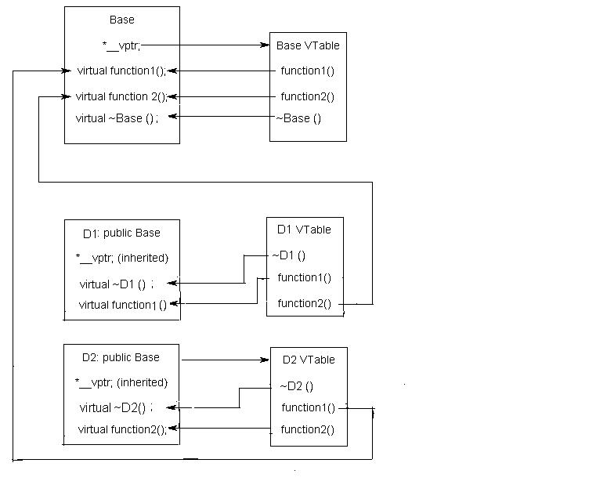

# Commonly Asked C++ Interview Questions | Set 2

### Q. Major Differences between JAVA and C++

There are lot of differences, some of the major differences are:

* Java has automatic garbage collection whereas C++ has destructors , which are automatically invoked when the object is destroyed.
* Java does not support pointers, templates, unions, operator overloading, structures etc.
* C++ has no in built support for threads, whereas in Java there is a Thread class that you inherit to create a new thread
* No goto in JAVA
* C++ support multiple inheritance, method overloading and operator overloading but JAVA only has method overloading.
* Java is *interpreted*and hence platform independent whereas C++ isn’t. At compilation time, Java Source code converts into JVM *byte code*. The interpreter executes this bytecode at run time and gives output. C++ run and compile using compiler which converts source code into machine level language.

### Q. What are C++ access specifiers ?

Access specifiers are used to define how the members (functions and variables) can be accessed outside the class.

* **Private:**Members declared as private are accessible only within the same class and they cannot be accessed outside the class they are declared. Child classes are also not allowed to access private members of parent.
* **Public:**Members declared as public are accessible from anywhere.
* **Protected:**Only the class and its child classes can access protected members.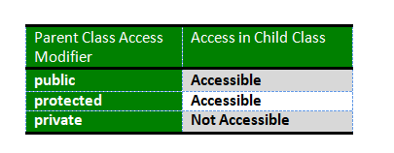

Do you know [What happens when more restrictive access is given to a derived class method in C++?](https://www.geeksforgeeks.org/what-happens-when-more-restrictive-access-is-given-in-a-derived-class-method-in-c/)

### 

### Q. Major C++ features

**Class:** Class is a blueprint of data and functions or methods. Class does not take any space.

* **Object:** Objects are basic run-time entities in an object oriented system, objects are instances of a class these are defined user defined data types.
* **Encapsulation and Data abstraction:** Wrapping up(combining) of data and functions into a single unit is known as encapsulation. The data is not accessible to the outside world and only those functions which are wrapping in the class can access it. This insulation of the data from direct access by the program is called data hiding or information hiding.
* **Data abstraction** – providing only needed information to the outside world and hiding implementation details. For example, consider a class Complex with public functions as getReal() and getImag(). We may implement the class as an array of size 2 or as two variables. The advantage of abstractions is, we can change implementation at any point, users of Complex class wont’t be affected as our method interface remains same. Had our implementation be public, we would not have been able to change it.
* **Inheritance:** Inheritance is the process by which objects of one class acquire the properties of objects of another class. It supports the concept of hierarchical classification. Inheritance provides reusability. This means that we can add additional features to an existing class without modifying it.
* **Polymorphism:** Polymorphism means ability to take more than one form. An operation may exhibit different behaviors in different instances. The behavior depends upon the types of data used in the operation.
* **Dynamic Binding:** In dynamic binding, the code to be executed in response to function call is decided at runtime. C++ has virtual functions to support this.
* **Message Passing:** Objects communicate with one another by sending and receiving information to each other. A message for an object is a request for execution of a procedure and therefore will invoke a function in the receiving object that generates the desired results. Message passing involves specifying the name of the object, the name of the function and the information to be sent.

### Q. [Structure vs class in C++](https://www.geeksforgeeks.org/g-fact-76/)

* In C++, a structure is same as class except the following differences:
  + Members of a class are private by default and members of struct are public by default.
  + When deriving a struct from a class/struct, default access-specifier for a base class/struct is public. And when deriving a class, default access specifier is private.

### Q. [Malloc() vs new](https://www.geeksforgeeks.org/malloc-vs-new/) / [Delete vs Free](https://www.geeksforgeeks.org/g-fact-30/)

Following are the differences between malloc() and operator new.

* new is an operator, while malloc() is a function.
* new returns exact data type, while malloc() returns void *.
* new calls constructors( class instances are initalized and deinitialized automatically), while malloc() does not( classes won’t get initalized or deinitialized automatically
* Syntax:
  1. int *n = new int(10); // initialization with new()
  2. str = (char *) malloc(15); //malloc()

**free( )** is used on resources allocated by malloc( ), or calloc( ) in C

**Delete** is used on resources allocated by new in C++

### Q. [Inline Functions](http://quiz.geeksforgeeks.org/inline-functions-cpp/)

C++ provides an inline functions to reduce the function call overhead. Inline function is a function that is expanded in line when it is called. When the inline function is called whole code of the inline function gets inserted or substituted at the point of inline function call. This substitution is performed by the C++ compiler at compile time. Inline function may increase efficiency if it is small.

The syntax for defining the function inline is:

inline return-type function-name(parameters)

{

// function code

}

*Remember, inlining is only a request to the compiler, not a command. Compiler can ignore the request for inlining.*

### 

### Q.[Friend class and function in C++](http://quiz.geeksforgeeks.org/friend-class-function-cpp/)

A friend class can access private and protected members of other class in which it is declared as friend. It is sometimes useful to allow a particular class to access private members of other class. For example a LinkedList class may be allowed to access private members of Node.

Friend Function Like friend class, a friend function can be given special grant to access private and protected members. A friend function can be:

a) A method of another class

b) A global function

**Important points about friend functions and classes:**

1) Friends should be used only for limited purpose. too many functions or external classes are declared as friends of a class with protected or private data, it lessens the value of encapsulation of separate classes in object-oriented programming.

2) Friendship is not mutual. If a class A is friend of B, then B doesn’t become friend of A automatically.

3) Friendship is not inherited (See this for more details)

4) The concept of friends is not there in Java.

### Q. [Function overloading](https://www.geeksforgeeks.org/function-overloading-in-c/) VS [Operator Overloading](http://quiz.geeksforgeeks.org/operator-overloading-c/)

Function overloading is a feature in C++ where two or more functions can have the same name but different type of parameters and  different number of parameters.

*Note: Overloading of functions with different return types are not allowed.*

Operating overloading allows us to  make operators to work for user defined classes. For example, we can overload an operator ‘+’ in a class like String so that we can concatenate two strings by just using +.

Other example classes where arithmetic operators may be overloaded are Complex Number, Fractional Number, Big Integer, etc.

|  |
| --- |
| class Complex {  private:   int real, imag;  public:   Complex(int r = 0, int i =0) {real = r; imag = i;}     // This is automatically called when '+' is used with   // between two Complex objects   Complex operator + (Complex const &obj) {   Complex res;   res.real = real + obj.real;   res.imag = imag + obj.imag;   return res;   }   void print() { cout << real << " + i" << imag << endl; }  };    int main()  {   Complex c1(10, 5), c2(2, 4);   Complex c3 = c1 + c2; // An example call to "operator+"   c3.print();  } |

### Q. [Copy Constructor](http://quiz.geeksforgeeks.org/copy-constructor-in-cpp/)

A copy constructor is a member function which initializes an object using another object of the same class. A copy constructor has the following general function prototype: ClassName (const ClassName &old_obj);

Point(int x1, int y1) { x = x1; y = y1; }

// Copy constructor

Point(const Point &p2) {x = p2.x; y = p2.y; }

When is copy constructor called?

In C++, a Copy Constructor may be called in following cases:

1. When an object of the class is returned by value.
2. When an object of the class is passed (to a function) by value as an argument.
3. When an object is constructed based on another object of the same class.
4. When compiler generates a temporary object.

***Can we make copy constructor private?***

*Yes, a copy constructor can be made private*

### 

### Q.What Is Inheritance?

Different kinds of objects often have a certain amount in common with each other. Yet each also defines additional features that make them different. Object-oriented programming allows classes to inherit commonly used state and behavior from other classes

### Q. What is Static Member?

Static is a keyword in C++ used to give special characteristics to an element. Static elements are allocated storage only once in a program lifetime in static storage area. And they have a scope till the program lifetime. Static Keyword can be used with following,

[**Interesting facts about Static Members Functions  in C++**](https://www.geeksforgeeks.org/some-interesting-facts-about-static-member-functions-in-c/)

* **static member functions do not have this pointer.**
* **A static member function cannot be virtual**
* **Member function declarations with the same name and the name parameter-type-list cannot be overloaded if any of them is a static member function declaration.**
* **static member function can not be declared const, volatile, or const volatile.**

**What is a namespace?**

In each scope, a name can only represent one entity. So, there cannot be two variables with the same name in the same scope. Using namespaces, we can create two variables or member functions having the same name.

A namespace definition begins with the keyword **namespace** followed by the namespace name as follows:

namespace namespace_name

{

int x, y; // code declarations where

// x and y are declared in

// namespace_name's scope

}

# Memory Layout of C Programs

A typical memory representation of C program consists of the following sections.

1. Text segment

2. Initialized data segment

3. Uninitialized data segment

4. Stack

5. Heap

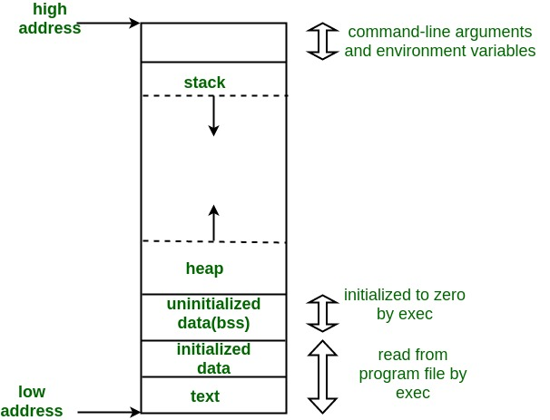

A typical memory layout of a running process

**1. Text Segment:**

A text segment , also known as a code segment or simply as text, is one of the sections of a program in an object file or in memory, which contains executable instructions.

As a memory region, a text segment may be placed below the heap or stack in order to prevent heaps and stack overflows from overwriting it.

Usually, the text segment is sharable so that only a single copy needs to be in memory for frequently executed programs, such as text editors, the C compiler, the shells, and so on. Also, the text segment is often read-only, to prevent a program from accidentally modifying its instructions.

**2. Initialized Data Segment:**

Initialized data segment, usually called simply the Data Segment. A data segment is a portion of virtual address space of a program, which contains the global variables and static variables that are initialized by the programmer.

Note that data segment is not read-only, since the values of the variables can be altered at run time.

This segment can be further classified into initialized read-only area and initialized read-write area.

For instance the global string defined by char s[] = “hello world” in C and a C statement like int debug=1 outside the main (i.e. global) would be stored in initialized read-write area. And a global C statement like const char* string = “hello world” makes the string literal “hello world” to be stored in initialized read-only area and the character pointer variable string in initialized read-write area.

Ex: static int i = 10 will be stored in data segment and global int i = 10 will also be stored in data segment

**3. Uninitialized Data Segment:**

Uninitialized data segment, often called the “bss” segment, named after an ancient assembler operator that stood for “block started by symbol.” Data in this segment is initialized by the kernel to arithmetic 0 before the program starts executing

uninitialized data starts at the end of the data segment and contains all global variables and static variables that are initialized to zero or do not have explicit initialization in source code.

For instance a variable declared static int i; would be contained in the BSS segment.

For instance a global variable declared int j; would be contained in the BSS segment.

**4. Stack:**

The stack area traditionally adjoined the heap area and grew the opposite direction; when the stack pointer met the heap pointer, free memory was exhausted. (With modern large address spaces and virtual memory techniques they may be placed almost anywhere, but they still typically grow opposite directions.)

The stack area contains the program stack, a LIFO structure, typically located in the higher parts of memory. On the standard PC x86 computer architecture it grows toward address zero; on some other architectures it grows the opposite direction. A “stack pointer” register tracks the top of the stack; it is adjusted each time a value is “pushed” onto the stack. The set of values pushed for one function call is termed a “stack frame”; A stack frame consists at minimum of a return address.

Stack, where automatic variables are stored, along with information that is saved each time a function is called. Each time a function is called, the address of where to return to and certain information about the caller’s environment, such as some of the machine registers, are saved on the stack. The newly called function then allocates room on the stack for its automatic and temporary variables. This is how recursive functions in C can work. Each time a recursive function calls itself, a new stack frame is used, so one set of variables doesn’t interfere with the variables from another instance of the function.

**5. Heap:**

Heap is the segment where dynamic memory allocation usually takes place.

The heap area begins at the end of the BSS segment and grows to larger addresses from there.The Heap area is managed by malloc, realloc, and free, which may use the brk and sbrk system calls to adjust its size (note that the use of brk/sbrk and a single “heap area” is not required to fulfill the contract of malloc/realloc/free; they may also be implemented using mmap to reserve potentially non-contiguous regions of virtual memory into the process’ virtual address space). The Heap area is shared by all shared libraries and dynamically loaded modules in a process.

**JAVA**

**Why is Java called the ‘Platform Independent Programming Language’?**

Platform independence means that execution of your program does not dependent on type of operating system(it could be any : Linux, windows, Mac ..etc). So compile code only once and run it on any System (In C/C++, we need to compile the code for every machine on which we run it). Java is both compiler(javac) and interpreter(jvm) based lauguage. Your java source code is first compiled into byte code using javac compiler. This byte code can be easily converted to equivalent machine code using JVM. JVM(Java Virtual Machine) is available in all operating systems we install. Hence, byte code generated by javac is universal and can be converted to machine code on any operating system, this is the reason why java is platform independent.

**Explain Final keyword in java?**

Final keyword in java is used to restrict usage of variable, class and method.  
   
Variable: Value of Final variable is constant, you cannot change it.  
Method: you can’t override a Final method.  
Class: you can’t inherit from Final class.

**When is the super keyword used?**  
   
super keyword is used to refer:

* immediate parent class constructor,
* immediate parent class variable,
* immediate parent class method.

Refer [this](http://quiz.geeksforgeeks.org/super-keyword/) for details.

**What is the difference between StringBuffer and String?**

String is an Immutable class, i.e. you can not modify its content once created. While StringBuffer is a mutable class, means you can change its content later. Whenever we alter content of String object, it creates a new string and refer to that,it does not modify the existing one. This is the reason that the performance with StringBuffer is better than with String.  
Refer [this](https://www.geeksforgeeks.org/g-fact-27-string-vs-stringbuilder-vs-stringbuffer/) for details.

**Why multiple inheritance is not supported in java?**

Java supports multiple inheritance but not through classes, it supports only through its interfaces. The reason for not supporting multiple inheritance is to avoid the conflict and complexity arises due to it and keep Java a Simple Object Oriented Language. If we recall [this in C++](https://www.geeksforgeeks.org/multiple-inheritance-in-c/), there is a special case of multiple inheritance (diamond problem) where you have a multiple inheritance with two classes which have methods in conflicts. So, Java developers decided to avoid such conflicts and didn’t allow multiple inheritance through classes at all.

**Can a top level class be private or protected?**

Top level classes in java can’t be private or protected, but inner classes in java can. The reason for not making a top level class as private is very obvious, because nobody can see a private class and thus they can not use it. Declaring a class as protected also doesn’t make any sense. The only difference between default visibility and protected visibility is that we can use it in any package by inheriting it. Since in java there is no such concept of package inheritance, defining a class as protected is no different from default.

**What is the difference between ‘throw’ and ‘throws’ in Java Exception Handling?**

Following are the differences between two:

* throw keyword is used to throw Exception from any method or static block whereas throws is used to indicate that which Exception can possibly be thrown by this method
* If any method throws checked Exception, then caller can either handle this exception(using try catch block )or can re throw it by declaring another ‘throws’ clause in method declaration.
* throw clause can be used in any part of code where you feel a specific exception needs to be thrown to the calling method

E.g.  
**throw**  
throw new Exception(“You have some exception”)  
throw new IOException(“Connection failed!!”)  
**throws**  
throws IOException, NullPointerException, ArithmeticException

**What is finalize() method?**  
   
Unlike c++ , we don’t need to destroy objects explicitly in Java. ‘[Garbage Collector](https://www.geeksforgeeks.org/garbage-collection-java/)‘ does that automatically for us. Garbage Collector checks if no references to an object exist, that object is assumed to be no longer required, and the memory occupied by the object can be freed. Sometimes an object can hold non-java resources such as file handle or database connection, then you want to make sure these resources are also released before object is destroyed. To perform such operation Java provide protected void finalize() in object class. You can override this method in your class and do the required tasks. Right before an object is freed, the java run time calls the finalize() method on that object. Refer [this](https://www.geeksforgeeks.org/garbage-collection-java/) for more details.

**Difference in Set and List interface?**

Set and List both are child interface of Collection interface. There are following two main differences between them

* List can hold duplicate values but Set doesn’t allow this.
* In List interface data is present in the order you inserted but in the case of Set insertion order is not preserved.

**What will happen if you put System.exit(0) on try or catch block? Will finally block execute?**  
   
By Calling System.exit(0) in try or catch block, we can skip the finally block. System.exit(int) method can throw a SecurityException. If Sysytem.exit(0) exits the JVM without throwing that exception then finally block will not execute. But, if System.exit(0) does throw security exception then finally block will be executed.

**Can we**[**Overload or Override static methods in java**](https://www.geeksforgeeks.org/can-we-overload-or-override-static-methods-in-java/)**?**

* **Overriding :** Overriding is related to run-time polymorphism. A subclass (or derived class) provides a specific implementation of a method in superclass (or base class) at runtime.
* **Overloading:** Overloading is related to compile time (or static) polymorphism. This feature allows different methods to have same name, but different signatures, especially number of input parameters and type of input paramaters.
* **Can we overload static methods?**The answer is **‘Yes’**. We can have two ore more static methods with same name, but differences in input parameters
* **Can we Override static methods in java?**We can declare static methods with same signature in subclass, but it is not considered overriding as there won’t be any run-time polymorphism. Hence the answer is **‘No’**. Static methods cannot be overridden because method overriding only occurs in the context of dynamic (i.e. runtime) lookup of methods. Static methods (by their name) are looked up statically (i.e. at compile-time).

Read [more](https://www.geeksforgeeks.org/can-we-overload-or-override-static-methods-in-java/)

**Why the main method is static in java?**  
The method is static because otherwise there would be ambiguity: which constructor should be called? Especially if your class looks like this:

public class JavaClass

{

protected JavaClass(int x)

{ }

public void main(String[] args)

{

}

}

Should the JVM call new JavaClass(int)? What should it pass for x? If not, should the JVM instantiate JavaClass without running any constructor method? because that will special-case your entire class – sometimes you have an instance that hasn’t been initialized, and you have to check for it in every method that could be called. There are just too many edge cases and ambiguities for it to make sense for the JVM to have to instantiate a class before the entry point is called. That’s why main is static.

**What happens if you remove static modifier from the main method?**  
Program compiles successfully . But at runtime throws an error “NoSuchMethodError”.

**What is the**[**scope of variables**](https://www.geeksforgeeks.org/variable-scope-in-java/)**in Java in following cases?**

* **Member Variables** (Class Level Scope) : The member variables must be declared inside class (outside any function). They can be directly accessed anywhere in class
* **Local Variables**(Method Level Scope) : Variables declared inside a method have method level scope and can’t be accessed outside the method.
* **Loop Variables**(Block Scope) : A variable declared inside pair of brackets “{” and “}” in a method has scope withing the brackets only.

Read [more](https://www.geeksforgeeks.org/variable-scope-in-java/)

**What is**[**“this” keyword in java**](http://quiz.geeksforgeeks.org/this-reference-in-java/)**?**  
Within an instance method or a constructor, this is a reference to the current object — the object whose method or constructor is being called. You can refer to any member of the current object from within an instance method or a constructor by using this.  
Usage of this keyword

* Used to refer current class instance variable.
* To invoke current class constructor.
* It can be passed as an argument in the method call.
* It can be passed as argument in the constructor call.
* Used to return the current class instance.
* Used to invoke current class method (implicitly)

**What is an**[**abstract class**](https://www.geeksforgeeks.org/abstract-classes-in-java/)**? How abstract classes are similar or different in Java from C++?**  
Abstract classes are classes that contain one or more abstract methods. An abstract method is a method that is declared, but contains no implementation. Abstract classes may not be instantiated, and require subclasses to provide implementations for the abstract methods.

* Like C++, in Java, an instance of an abstract class cannot be created, we can have references of abstract class type though.
* Like C++, an abstract class can contain constructors in Java. And a constructor of abstract class is called when an instance of a inherited class is created
* In Java, we can have an abstract class without any abstract method. This allows us to create classes that cannot be instantiated, but can only be inherited.
* Abstract classes can also have final methods (methods that cannot be overridden). For example, the following program compiles and runs fine.

Read [more](https://www.geeksforgeeks.org/abstract-classes-in-java/)

**Abstract class vs Interface**

* **Type of methods:** Interface can have only abstract methods. Abstract class can have abstract and non-abstract methods. From Java 8, it can have default and static methods also.
* **Final Variables:** Variables declared in a Java interface are by default final. An abstract class may contain non-final variables.
* **Type of variables:** Abstract class can have final, non-final, static and non-static variables. Interface has only static and final variables.
* **Implementation:** Abstract class can provide the implementation of interface. Interface can’t provide the implementation of abstract class.
* **Inheritance vs Abstraction:** A Java interface can be implemented using keyword “implements” and abstract class can be extended using keyword “extends”.
* **Multiple implementation:** An interface can extend another Java interface only, an abstract class can extend another Java class and implement multiple Java interfaces.
* **Accessibility of Data Members:** Members of a Java interface are public by default. A Java abstract class can have class members like private, protected, etc.

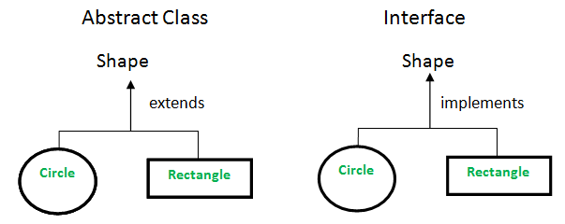

**Which class is the superclass for every class ?**  
Object class

[**Can we overload main() method?**](https://www.geeksforgeeks.org/gfact-48-overloading-main-in-java/)  
The main method in Java is no extra-terrestrial method. Apart from the fact that main() is just like any other method & can be overloaded in a similar manner, JVM always looks for the method signature to launch the program.

* The normal main method acts as an entry point for the JVM to start the execution of program.
* We can overload the main method in Java. But the program doesn’t execute the overloaded main method when we run your program, we need to call the overloaded main method from the actual main method only.

Read [more](https://www.geeksforgeeks.org/gfact-48-overloading-main-in-java/)

**What is**[**object cloning**](http://quiz.geeksforgeeks.org/cloning-in-java/)**?**  
Object cloning means to create an exact copy of the original object. If a class needs to support cloning, it must implement java.lang.Cloneable interface and override clone() method from Object class. Syntax of the clone() method is :

protected Object clone() throws CloneNotSupportedException

If the object’s class doesn’t implement Cloneable interface then it throws an exception ‘CloneNotSupportedException’ .

Read [more](http://quiz.geeksforgeeks.org/cloning-in-java/)

**How is**[**inheritance in C++  different from Java?**](https://www.geeksforgeeks.org/comparison-of-inheritance-in-c-and-java/)

1. In Java, all classes inherit from the Object class directly or indirectly. Therefore, there is always a single inheritance tree of classes in Java, and Object class is root of the tree.
2. In Java, members of the grandparent class are not directly accessible. See [this G-Fact](https://www.geeksforgeeks.org/accessing-grandparents-member-in-java-using-super/) for more details.
3. The meaning of protected member access specifier is somewhat different in Java. In Java, protected members of a class “A” are accessible in other class “B” of same package, even if B doesn’t inherit from A (they both have to be in the same package).
4. Java uses *extends*keyword for inheritance. Unlike C++, Java doesn’t provide an inheritance specifier like public, protected or private. Therefore, we cannot change the protection level of members of base class in Java, if some data member is public or protected in base class then it remains public or protected in derived class. Like C++, private members of base class are not accessible in derived class.  
   Unlike C++, in Java, we don’t have to remember those rules of inheritance which are combination of base class access specifier and inheritance specifier.
5. In Java, methods are virtual by default. In C++, we explicitly use virtual keyword. See [this G-Fact](https://www.geeksforgeeks.org/g-fact-43/) for more details.
6. Java uses a separate keyword *interface*for interfaces, and *abstract*keyword for abstract classes and abstract functions.
7. Unlike C++, Java doesn’t support multiple inheritance. A class cannot inherit from more than one class. A class can implement multiple interfaces though.
8. In C++, default constructor of parent class is automatically called, but if we want to call parametrized constructor of a parent class, we must use [Initializer list](https://www.geeksforgeeks.org/when-do-we-use-initializer-list-in-c/). Like C++, default constructor of the parent class is automatically called in Java, but if we want to call parameterized constructor then we must use super to call the parent constructor.

See examples [here](https://www.geeksforgeeks.org/comparison-of-inheritance-in-c-and-java/)

**Why method overloading is not possible by changing the return type in java?**  
In C++ and Java, functions can not be overloaded if they differ only in the return type . The return type of functions is not a part of the mangled name which is generated by the compiler for uniquely identifying each function. The No of arguments, Type of arguments & Sequence of arguments are the parameters which are used to generate the unique mangled name for each function. It is on the basis of these unique mangled names that compiler can understand which function to call even if the names are same(overloading).

**Can we override private methods in Java?**  
No, a private method cannot be overridden since it is not visible from any other class. Read [more](https://www.geeksforgeeks.org/can-override-private-methods-java/)

**What is**[**blank final variable**](https://www.geeksforgeeks.org/blank-final-in-java/)**?**  
A final variable in Java can be assigned a value only once, we can assign a value either in declaration or later.

final int i = 10;

i = 30; // Error because i is final.

A **blank final** variable in Java is a [final](https://www.geeksforgeeks.org/g-fact-48/) variable that is not initialized during declaration. Below is a simple example of blank final.

// A simple blank final example

final int i;

i = 30;

Read [more](https://www.geeksforgeeks.org/blank-final-in-java/)

**What is**[**“super” keyword in java**](http://quiz.geeksforgeeks.org/super-keyword/)**?**  
The super keyword in java is a reference variable that is used to refer parent class objects. The keyword “super” came into the picture with the concept of Inheritance. Whenever you create the instance of subclass, an instance of parent class is created implicitly i.e. referred by super reference variable.  
Various scenarios of using java super Keyword:

* super is used to refer immediate parent instance variable
* super is used to call parent class method
* super() is used to call immediate parent constructor

Read [more](http://quiz.geeksforgeeks.org/super-keyword/)

**What is**[**static variable in Java**](https://www.geeksforgeeks.org/static-class-in-java/)**?**  
The static keyword in java is used for memory management mainly. We can apply java static keyword with variables, methods, blocks and nested class. The static keyword belongs to the class than instance of the class.

The static can be:

* variable (also known as class variable)
* method (also known as class method)
* block
* nested class

**Differences between**[**HashMap and HashTable in Java**](http://quiz.geeksforgeeks.org/differences-between-hashmap-and-hashtable-in-java/)**.**  
1. HashMap is non synchronized. It is not-thread safe and can’t be shared between many threads without proper synchronization code whereas Hashtable is synchronized. It is thread-safe and can be shared with many threads.  
2. HashMap allows one null key and multiple null values whereas Hashtable doesn’t allow any null key or value.  
3. HashMap is generally preferred over HashTable if thread synchronization is not needed  
[Read more](http://quiz.geeksforgeeks.org/differences-between-hashmap-and-hashtable-in-java/)

**How are Java**[**objects stored in memory**](https://www.geeksforgeeks.org/g-fact-46/)**?**  
In Java, all objects are dynamically allocated on **Heap**. This is different from C++ where objects can be allocated memory either on Stack or on Heap. In C++, when we allocate abject using new(), the object is allocated on Heap, otherwise on Stack if not global or static.  
In Java, when we only declare a variable of a class type, only a reference is created (memory is not allocated for the object). To allocate memory to an object, we must use new(). So the object is always allocated memory on heap.  Read [more](https://www.geeksforgeeks.org/g-fact-46/)

**What are C++ features missing in Java?**

Following features of C++ are not there in Java.

No pointers  
No sizeof operator  
No scope resolution operator  
[Local variables in functions cannot be static](https://www.geeksforgeeks.org/g-fact-47/)  
No Multiple Inheritance  
No [Operator Overloading](http://quiz.geeksforgeeks.org/operator-overloading-c/)  
No [preprocessor and macros](https://www.geeksforgeeks.org/interesting-facts-preprocessors-c/)  
No user suggested [inline functions](http://quiz.geeksforgeeks.org/inline-functions-cpp/)  
No goto  
No [default arguments](http://quiz.geeksforgeeks.org/default-arguments-c/)  
No unsigned int in Java  
No -> operator in java  
No stack allocated objects in java  
No delete operator in java due to java’s garbage collection  
No destructor in java  
No typedef in java  
No global variables, no global function because java is pure OO.  
No friend functions  
No friend classes  
No templates in java

# Comparison of Inheritance in C++ and Java

The purpose of inheritance is same in C++ and Java. Inheritance is used in both languages for reusing code and/or creating is-a relationship. There are following differences in the way both languages provide support for inheritance.

**1)** In Java, all classes inherit from the [Object class](http://download.oracle.com/javase/1.5.0/docs/api/java/lang/Object.html)directly or indirectly. Therefore, there is always a single inheritance tree of classes in Java, and [Object class](http://download.oracle.com/javase/1.5.0/docs/api/java/lang/Object.html)is root of the tree. In Java, if we create a class that doesn’t inherit from any class then it automatically inherits from [Object class](http://download.oracle.com/javase/1.5.0/docs/api/java/lang/Object.html). In C++, there is forest of classes; when we create a class that doesn’t inherit from anything, we create a new tree in forest.

Following Java example shows that Test class automatically inherits from Object class.

|  |
| --- |
| class Test {      // members of test  }  class Main {    public static void main(String[] args) {      Test t = new Test();      System.out.println("t is instanceof Object: " + (t instanceof Object));    }  } |

Output:

t is instance of Object: true

**2)** In Java, members of the grandparent class are not directly accessible. See [this G-Fact](https://www.geeksforgeeks.org/accessing-grandparents-member-in-java-using-super/) for more details.

**3)** The meaning of protected member access specifier is somewhat different in Java. In Java, protected members of a class “A” are accessible in other class “B” of same package, even if B doesn’t inherit from A (they both have to be in the same package). For example, in the following program, protected members of A are accessible in B.

|  |
| --- |
| // filename B.java  class A {      protected int x = 10, y = 20;  }    class B {      public static void main(String args[]) {          A a = new A();          System.out.println(a.x + " " + a.y);      }  } |

**4)**Java uses *extends*keyword for inheritence. Unlike C++, Java doesn’t provide an inheritance specifier like public, protected or private. Therefore, we cannot change the protection level of members of base class in Java, if some data member is public or protected in base class then it remains public or protected in derived class. Like C++, private members of base class are not accessible in derived class.  
Unlike C++, in Java, we don’t have to remember those rules of inheritance which are combination of base class access specifier and inheritance specifier.

**5)** In Java, methods are virtual by default. In C++, we explicitly use virtual keyword. See [this G-Fact](https://www.geeksforgeeks.org/g-fact-43/) for more details.

**6)** Java uses a separate keyword *interface*for interfaces, and *abstract*keyword for abstract classes and abstract functions.

Following is a Java abstract class example.

|  |
| --- |
| // An abstract class example  abstract class myAbstractClass {       // An abstract method     abstract void myAbstractFun();       // A normal method     void fun() {        System.out.println("Inside My fun");     }  }    public class myClass extends myAbstractClass {     public void myAbstractFun() {        System.out.println("Inside My fun");     }  } |

Following is a Java interface example

|  |
| --- |
| // An interface example  public interface myInterface {     // myAbstractFun() is public and abstract, even if we don't use these keywords     void myAbstractFun();  // is same as public abstract void myAbstractFun()  }    // Note the implements keyword also.  public class myClass implements myInterface {     public void myAbstractFun() {        System.out.println("Inside My fun");     }  } |

**7)** Unlike C++, Java doesn’t support multiple inheritance. A class cannot inherit from more than one class. A class can implement multiple interfaces though.

**8 )**In C++, default constructor of parent class is automatically called, but if we want to call parametrized constructor of a parent class, we must use [Initializer list](https://www.geeksforgeeks.org/when-do-we-use-initializer-list-in-c/). Like C++, default constructor of the parent class is automatically called in Java, but if we want to call parametrized constructor then we must use super to call the parent constructor. See following Java example.

|  |
| --- |
| package main;    class Base {      private int b;      Base(int x) {          b = x;          System.out.println("Base constructor called");      }  }    class Derived extends Base {      private int d;      Derived(int x, int y) {          // Calling parent class parameterized constructor          // Call to parent constructor must be the first line in a Derived class          super(x);          d = y;          System.out.println("Derived constructor called");      }  }    class Main{      public static void main(String[] args) {        Derived obj = new Derived(1, 2);      }  } |

Output:

Base constructor called

Derived constructor called

# Commonly Asked Data Structure Interview Questions | Set 1

**What is a Data Structure?**  
A data structure is a way of organizing the data so that the data can be used efficiently. Different kinds of data structures are suited to different kinds of applications, and some are highly specialized to specific tasks. For example, B-trees are particularly well-suited for implementation of databases, while compiler implementations usually use hash tables to look up identifiers. (Source: [Wiki Page](http://en.wikipedia.org/wiki/Data_structure))

**What are linear and non linear data Structures?**

* **Linear:** A data structure is said to be linear if its elements form a sequence or a linear list. Examples: Array. Linked List, Stacks and Queues
* **Non-Linear:**A data structure is said to be non-linear if traversal of nodes is nonlinear in nature. Example: Graph and Trees.

**What are the various operations that can be performed on different Data Structures?**

* **Insertion** ? Add a new data item in the given collection of data items.
* **Deletion** ? Delete an existing data item from the given collection of data items.
* **Traversal** ? Access each data item exactly once so that it can be processed.
* **Searching** ? Find out the location of the data item if it exists in the given collection of data items.
* **Sorting** ? Arranging the data items in some order i.e. in ascending or descending order in case of numerical data and in dictionary order in case of alphanumeric data.

[**How is an Array different from Linked List?**](https://www.geeksforgeeks.org/linked-list-vs-array/)

* The size of the arrays is fixed, Linked Lists are Dynamic in size.
* Inserting and deleting a new element in an array of elements is expensive, Whereas both insertion and deletion can easily be done in Linked Lists.
* Random access is not allowed in Linked Listed.
* Extra memory space for a pointer is required with each element of the Linked list.
* Arrays have better cache locality that can make a pretty big difference in performance.

**What is Stack and where it can be used?**

Stack is a linear data structure which the order LIFO(Last In First Out) or FILO(First In Last Out) for accessing elements. Basic operations of stack are : **Push, Pop , Peek**

Applications of Stack:

1. [Infix to Postfix Conversion using Stack](http://geeksquiz.com/stack-set-2-infix-to-postfix/)
2. [Evaluation of Postfix Expression](http://geeksquiz.com/stack-set-4-evaluation-postfix-expression/)
3. [Reverse a String using Stack](http://geeksquiz.com/stack-set-3-reverse-string-using-stack/)
4. [Implement two stacks in an array](https://www.geeksforgeeks.org/implement-two-stacks-in-an-array/)
5. [Check for balanced parentheses in an expression](https://www.geeksforgeeks.org/check-for-balanced-parentheses-in-an-expression/)

**What is a Queue, how it is different from stack and how is it implemented?**

[Queue](http://en.wikipedia.org/wiki/Queue_%28data_structure%29)is a linear structure which follows the order is **F**irst **I**n **F**irst **O**ut (FIFO) to access elements. Mainly the following are basic operations on queue: **Enqueue, Dequeue**, **Front, Rear**  
The difference between stacks and queues is in removing. In a stack we remove the item the most recently added; in a queue, we remove the item the least recently added. Both Queues and Stacks can be implemented using Arrays and Linked Lists.

**What are Infix, prefix, Postfix notations?**

* **Infix notation:**X **+** Y – Operators are written in-between their operands. This is the usual way we write expressions. An expression such as

A * ( B + C ) / D

* **Postfix notation (also known as “Reverse Polish notation”):**X Y **+**Operators are written after their operands. The infix expression given above is equivalent to

A B C + * D/

* **Prefix notation (also known as “Polish notation”):**+ X YOperators are written before their operands. The expressions given above are equivalent to

/ * A + B C D

Converting between these notations: [Click here](http://quiz.geeksforgeeks.org/stack-set-2-infix-to-postfix/)

**What is a Linked List and What are its types?**

A linked list is a linear data structure (like arrays) where each element is a separate object. Each element (that is node) of a list is comprising of two items – the data and a reference to the next node.Types of Linked List :

1. **Singly Linked List :**In this type of linked list, every node stores address or reference of next node in list and the last node has next address or reference as NULL. For example 1->2->3->4->NULL
2. **Doubly Linked List :**Here,here are two references associated with each node, One of the reference points to the next node and one to the previous node. Eg. NULL<-1<->2<->3->NULL
3. **Circular Linked List :**Circular linked list is a linked list where all nodes are connected to form a circle. There is no NULL at the end. A circular linked list can be a singly circular linked list or doubly circular linked list. Eg. 1->2->3->1 [The next pointer of last node is pointing to the first]

**Which data structures are used for BFS and DFS of a graph?**

* [Queue is used for BFS](https://www.geeksforgeeks.org/breadth-first-traversal-for-a-graph/)
* Stack is used for DFS. [DFS can also be implemented using recursion](https://www.geeksforgeeks.org/depth-first-traversal-for-a-graph/) (Note that recursion also uses function call stack).

**Can doubly linked be implemented using a single pointer variable in every node?**

**Ordinary Representation:**  
Node A:  
prev = NULL, next = add(B) // previous is NULL and next is address of B

Node B:  
prev = add(A), next = add(C) // previous is address of A and next is address of C

Node C:  
prev = add(B), next = add(D) // previous is address of B and next is address of D

Node D:  
prev = add(C), next = NULL // previous is address of C and next is NULL

**XOR List Representation:**  
Let us call the address variable in XOR representation npx (XOR of next and previous)

Node A:  
npx = 0 XOR add(B) // bitwise XOR of zero and address of B

Node B:  
npx = add(A) XOR add(C) // bitwise XOR of address of A and address of C

Node C:  
npx = add(B) XOR add(D) // bitwise XOR of address of B and address of D

Node D:  
npx = add(C) XOR 0 // bitwise XOR of address of C and 0

**Traversal of XOR Linked List:**  
We can traverse the XOR list in both forward and reverse direction. While traversing the list we need to remember the address of the previously accessed node in order to calculate the next node’s address. For example when we are at node C, we must have address of B. XOR of add(B) and *npx*of C gives us the add(D). The reason is simple: npx(C) is “add(B) XOR add(D)”. If we do xor of npx(C) with add(B), we get the result as “add(B) XOR add(D) XOR add(B)” which is “add(D) XOR 0” which is “add(D)”. So we have the address of next node. Similarly we can traverse the list in backward direction.

**How to implement a stack using queue?**

A stack can be implemented using two queues. Let stack to be implemented be ‘s’ and queues used to implement be ‘q1’ and ‘q2’. Stack ‘s’ can be implemented in two ways:

* Method 1 (By making push operation costly)
* Method 2 (By making pop operation costly) See [Implement Stack using Queues](https://www.geeksforgeeks.org/implement-stack-using-queue/)

**How to implement a queue using stack?**

A queue can be implemented using two stacks. Let queue to be implemented be q and stacks used to implement q be stack1 and stack2. q can be implemented in two ways:

* Method 1 (By making enQueue operation costly)
* Method 2 (By making deQueue operation costly) See [Implement Queue using Stacks](https://www.geeksforgeeks.org/queue-using-stacks/)

**Which Data Structure Should be used for implementiong LRU cache?**

We use two data structures to implement an LRU Cache.

1. **Queue** which is implemented using a doubly linked list. The maximum size of the queue will be equal to the total number of frames available (cache size).The most recently used pages will be near rear end and least recently pages will be near front end.
2. **A Hash** with page number as key and address of the corresponding queue node as value. See [How to implement LRU caching scheme? What data structures should be used?](https://www.geeksforgeeks.org/implement-lru-cache/)

**How to check if a given Binary Tree is BST or not?**  
If inorder traversal of a binary tree is sorted, then the binary tree is BST. The idea is to simply do inorder traversal and while traversing keep track of previous key value. If current key value is greater, then continue, else return false. See [A program to check if a binary tree is BST or not](https://www.geeksforgeeks.org/a-program-to-check-if-a-binary-tree-is-bst-or-not/) for more details.

**Linked List Questions**

* [Linked List Insertion](http://quiz.geeksforgeeks.org/linked-list-set-2-inserting-a-node/)
* [Linked List Deletion](http://quiz.geeksforgeeks.org/linked-list-set-3-deleting-node/)
* [middle of a given linked list](https://www.geeksforgeeks.org/write-a-c-function-to-print-the-middle-of-the-linked-list/)
* [Nth node from the end of a Linked List](https://www.geeksforgeeks.org/nth-node-from-the-end-of-a-linked-list/)

**Tree Traversal Questions**

* [Inorder](https://www.geeksforgeeks.org/618/)
* [Preorder and Postoder Traversals](https://www.geeksforgeeks.org/618/)
* [Level order traversal](https://www.geeksforgeeks.org/level-order-tree-traversal/)
* [Height of Binary Tree](https://www.geeksforgeeks.org/write-a-c-program-to-find-the-maximum-depth-or-height-of-a-tree/)

**Convert a DLL to Binary Tree in-place**  
See [In-place conversion of Sorted DLL to Balanced BST](https://www.geeksforgeeks.org/in-place-conversion-of-sorted-dll-to-balanced-bst/)

**Convert Binary Tree to DLL in-place**  
See [Convert a given Binary Tree to Doubly Linked List | Set 1](https://www.geeksforgeeks.org/in-place-convert-a-given-binary-tree-to-doubly-linked-list/), [Convert a given Binary Tree to Doubly Linked List | Set 2](https://www.geeksforgeeks.org/convert-a-given-binary-tree-to-doubly-linked-list-set-2/)

**Delete a given node in a singly linked list**  
[Given only a pointer to a node to be deleted in a singly linked list, how do you delete it?](https://www.geeksforgeeks.org/in-a-linked-list-given-only-a-pointer-to-a-node-to-be-deleted-in-a-singly-linked-list-how-do-you-delete-it/)

**Reverse a Linked List**  
[Write a function to reverse a linked list](https://www.geeksforgeeks.org/write-a-function-to-reverse-the-nodes-of-a-linked-list/)

**Detect Loop in a Linked List**  
[Write a C function to detect loop in a linked list](https://www.geeksforgeeks.org/write-a-c-function-to-detect-loop-in-a-linked-list/).

**Which data structure is used for dictionary and spell checker?**  
[Data Structure for Dictionary and Spell Checker?](https://www.geeksforgeeks.org/data-structure-dictionary-spell-checker/)

# OOP

# Commonly Asked OOP Interview Questions | Set 1

**What is Object Oriented Programming?**  
**O**bject **O**riented **P**rogramming (OOP) is a programming paradigm where the complete software operates as a bunch of objects talking to each other. An object is a collection of data and methods that operate on its data.

**Why OOP?**  
The main advantage of OOP is better manageable code that covers following.

1) The overall understanding of the software is increased as the distance between the language spoken by developers and that spoken by users.

2) Object orientation eases maintenance by the use of encapsulation.   One can easily change the underlying representation by keeping the methods same.

OOP paradigm is mainly useful for relatively big software.

**What are main features of OOP?**  
Encapsulation  
Polymorphism  
Inheritance

**What is encapsulation?**  
Encapsulation is referred to one of the following two notions.  
1) Data hiding: A language feature to restrict access to members of an object. For example, private and protected members in C++.  
2) Bundling of data and methods together: Data and methods that operate on that data are bundled together.

**What is Polymorphism? How is it supported by C++?**  
Polymorphism means that some code or operations or objects behave differently in different contexts. In C++,  following features support polymorphism.

*Compile Time Polymorphism:*Compile time polymorphism means compiler knows which function should be called when a polymorphic call is made.  C++ supports compiler time polymorphism by supporting features like templates, function overloading and default arguments.

*Run Time Polymorphism:*Run time polymorphism is supported by virtual functions*.*The idea is, [virtual functions](http://en.wikipedia.org/wiki/Virtual_function) are called according to the type of object pointed or referred, not according to the type of pointer or reference. In other words, virtual functions are resolved late, at runtime.

**What is**[**Inheritance**](http://en.wikipedia.org/wiki/Inheritance_%28object-oriented_programming%29)**? What is the purpose?**  
The idea of inheritance is simple, a class is based on another class and uses data and implementation of the other class.  
The purpose of inheritance is Code Reuse.

**What is Abstraction?**  
The first thing with which one is confronted when writing programs is the problem. Typically we are confronted with “real-life” problems and we want to make life easier by providing a program for the problem. However, real-life problems are nebulous and the first thing we have to do is to try to understand the problem to separate necessary from unnecessary details: We try to obtain our own abstract view, or model, of the problem. This process of modeling is called abstraction.

# DBMS

# Commonly asked DBMS interview questions | Set 1

**What are advantages of DBMS over traditional file based systems?**  
**Ans:** Database management systems were developed to handle the following difficulties of typical Fille-processing systems supported by conventional operating systems.  
1. Data redundancy and inconsistency  
2. Difficulty in accessing data  
3. Data isolation – multiple files and formats  
4. Integrity problems  
5. Atomicity of updates  
6. Concurrent access by multiple users  
7. Security problems  
Source: <http://cs.nyu.edu/courses/spring01/G22.2433-001/mod1.2.pdf>

**What are super, primary, candidate and foreign keys?**  
**Ans:**A [superkey](http://en.wikipedia.org/wiki/Superkey)is a set of attributes of a relation schema upon which all attributes of the schema are functionally dependent. No two rows can have the same value of super key attributes.  
A [Candidate key](http://en.wikipedia.org/wiki/Candidate_key) is minimal superkey, i.e., no proper subset of Candidate key attributes can be a superkey.  
A [Primary Key](http://publib.boulder.ibm.com/infocenter/db2luw/v8/index.jsp?topic=/com.ibm.db2.udb.doc/admin/c0004799.htm) is one of the candidate keys. One of the candidate keys is selected as most important and becomes the primary key. There cannot be more that one primary keys in a table.  
[Foreign key](http://en.wikipedia.org/wiki/Foreign_key) is a field (or collection of fields) in one table that uniquely identifies a row of another table. See [this](http://www.w3schools.com/sql/sql_foreignkey.asp)for an example.

**What is the difference between primary key and unique constraints?**  
**Ans:** Primary key cannot have NULL value, the unique constraints can have NULL values. There is only one primary key in a table, but there can be multiple unique constrains.

**What is database normalization?**  
**Ans:**It is a process of analyzing the given relation schemas based on their functional dependencies and primary keys to achieve the following desirable properties:  
1) Minimizing Redundancy  
2) Minimizing the Insertion, Deletion, And Update Anomalies  
Relation schemas that do not meet the properties are decomposed into smaller relation schemas that could meet desirable properties.  
Source: <http://cs.tsu.edu/ghemri/CS346/ClassNotes/Normalization.pdf>

**What is SQL?**  
SQL is Structured Query Language designed for inserting and modifying in a [relational database system](http://en.wikipedia.org/wiki/Relational_database_management_system).

**What are the differences between DDL, DML and DCL in SQL?  
Ans:** Following are some details of three.  
***DDL***stands for Data Definition Language. SQL queries like CREATE, ALTER, DROP and RENAME come under this.  
***DML***stands for Data Manipulation Language. SQL queries like SELECT, INSERT and UPDATE come under this.  
***DCL*** stands for Data Control Language. SQL queries like GRANT and REVOKE come under this.

**What is the difference between having and where clause?**  
**Ans:** HAVING is used to specify a condition for a group or an aggregate function used in select statement. The WHERE clause selects before grouping. The HAVING clause selects rows after grouping. Unlike HAVING clause, the WHERE clause cannot contain aggregate functions. (See [this](http://newtonapples.com/difference-clause-clause/)for examples).  
See [Having vs Where Clause?](http://quiz.geeksforgeeks.org/having-vs-where-clause/) for more details

**How to print duplicate rows in a table?**  
**Ans:**See <http://quiz.geeksforgeeks.org/how-to-print-duplicate-rows-in-a-table/>

**What is Join?**  
**Ans:** An SQL Join is used to combine data from two or more tables, based on a common field between them. For example, consider the following two tables.

**Table –** Student Table

|  |  |  |
| --- | --- | --- |
| ***ENROLLNO*** | ***STUDENTNAME*** | ***ADDRESS*** |
| 1000 | geek1 | geeksquiz1 |
| 1001 | geek2 | geeksquiz2 |
| 1002 | geek3 | geeksquiz3 |

**Table –** StudentCourse Table

|  |  |
| --- | --- |
| ***COURSEID*** | ***ENROLLNO*** |
| 1 | 1000 |
| 2 | 1000 |
| 3 | 1000 |
| 1 | 1002 |
| 2 | 1003 |

Following is join query that shows names of students enrolled in different courseIDs.

SELECT StudentCourse.CourseID, Student.StudentName

FROM StudentCourse

INNER JOIN Student

ON StudentCourse.EnrollNo = Student.EnrollNo

ORDER BY StudentCourse.CourseID;

The above query would produce following result.

|  |  |
| --- | --- |
| ***COURSEID*** | ***STUDENTNAME*** |
| 1 | geek1 |
| 1 | geek3 |
| 2 | geek1 |
| 3 | geek1 |

**What is Identity?**  
**Ans:** Identity (or AutoNumber) is a column that automatically generates numeric values. A start and increment value can be set, but most DBA leave these at 1. A GUID column also generates numbers; the value of this cannot be controlled. Identity/GUID columns do not need to be indexed.

**Syntax:**

IDENTITY [( seed, increment)]

**Seed:** Starting value of a column.

Default value is 1.

**Increment:** Incremental value that is

added to the identity value of the previous

row that was loaded. The default value 1.

CREATE TABLE Persons (

Personid int IDENTITY(1,1) PRIMARY KEY,

LastName varchar(255) NOT NULL,

FirstName varchar(255),

Age int

);

**What is a view in SQL? How to create one**  
**Ans:** A [view](http://en.wikipedia.org/wiki/View_(SQL))is a virtual table based on the result-set of an SQL statement. We can create using create view syntax.

CREATE VIEW view_name AS

SELECT column_name(s)

FROM table_name

WHERE condition

**What are the uses of view?**  
**1.** Views can represent a subset of the data contained in a table; consequently, a view can limit the degree of exposure of the underlying tables to the outer world: a given user may have permission to query the view, while denied access to the rest of the base table.  
**2.** Views can join and simplify multiple tables into a single virtual table  
**3.** Views can act as aggregated tables, where the database engine aggregates data (sum, average etc.) and presents the calculated results as part of the data  
**4.** Views can hide the complexity of data; for example a view could appear as Sales2000 or Sales2001, transparently partitioning the actual underlying table  
**5.** Views take very little space to store; the database contains only the definition of a view, not a copy of all the data which it presents.  
**6.** Depending on the SQL engine used, views can provide extra security  
Source: [Wiki Page](http://en.wikipedia.org/wiki/View_(SQL))

**What is a Trigger?**  
**Ans:**A [Trigger](http://en.wikipedia.org/wiki/Database_trigger) is a code that associated with insert, update or delete operations. The code is executed automatically whenever the associated query is executed on a table. Triggers can be useful to maintain integrity in database.

**What is a stored procedure?**  
**Ans:** A [stored procedure](http://en.wikipedia.org/wiki/Stored_procedure) is like a function that contains a set of operations compiled together. It contains a set of operations that are commonly used in an application to do some common database tasks.

**What is the difference between Trigger and Stored Procedure?**  
**Ans:** Unlike Stored Procedures, Triggers cannot be called directly. They can only be associated with queries.

**What is a transaction? What are ACID properties?**  
**Ans:** A [Database Transaction](http://en.wikipedia.org/wiki/Database_transaction) is a set of database operations that must be treated as whole, means either all operations are executed or none of them.  
An example can be bank transaction from one account to another account. Either both debit and credit operations must be executed or none of them.  
[ACID](http://en.wikipedia.org/wiki/ACID)(Atomicity, Consistency, Isolation, Durability) is a set of properties that guarantee that database transactions are processed reliably.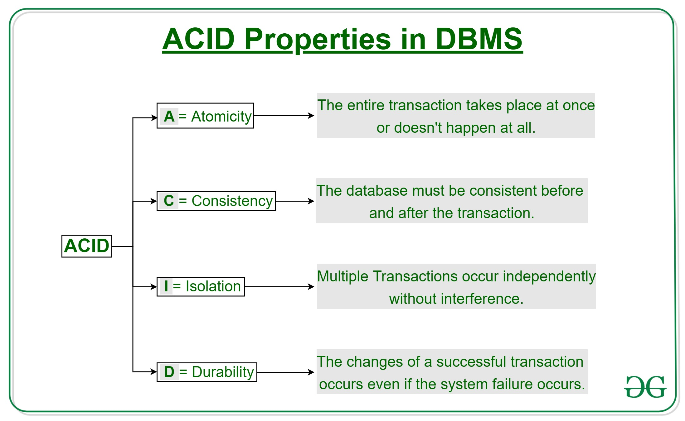

**What are indexes?**  
**Ans:** A [database index](http://en.wikipedia.org/wiki/Database_index) is a data structure that improves the speed of data retrieval operations on a database table at the cost of additional writes and the use of more storage space to maintain the extra copy of data.  
Data can be stored only in one order on disk. To support faster access according to different values, faster search like binary search for different values is desired, For this purpose, indexes are created on tables. These indexes need extra space on disk, but they allow faster search according to different frequently searched values.

**What are clustered and non-clustered Indexes?**  
**Ans:** Clustered indexes is the index according to which data is physically stored on disk. Therefore, only one clustered index can be created on a given database table.  
Non-clustered indexes don’t define physical ordering of data, but logical ordering. Typically, a tree is created whose leaf point to disk records. [B-Tree](http://en.wikipedia.org/wiki/B-tree) or [B+ tree](http://en.wikipedia.org/wiki/B+_tree) are used for this purpose

# SQL Interview Questions

1. **What is SQL?**  
   SQL stands for Structured Query Language. It is a language used to interact with the database, i.e to create a database, to create a table in the database, to retrieve data or update a table in the database etc. SQL is an ANSI(American National Standards Institute) standard. Using SQL, we can do many things, for example – we can execute queries, we can insert records in a table, we can update records, we can create a database, we can create a table, we can delete a table etc.
2. **What is a Database?**  
   A Database is defined as a structured form of data which is stored in a computer or data in an organised manner and can be accessed in various ways. It is also the collection of schemas, tables, queries, views etc. Database helps us in easily storing, accessing and manipulation of data held in a computer. The Database Management System allows a user to interact with the database.
3. **Does SQL support programming language features ?**  
   It is true that SQL is a language but it does not support programming as it is not a programming language, it is a command  language. We do not have conditional statements in SQL like for loops or if..else, we only have commands which we can use to query, update , delete etc. data in the database. SQL allows us to manipulate data in a database.
4. **What are the differences between SQL and PL/SQL?**  
   Ans: Some common differences between SQL and PL/SQL are as shown below:

|  |  |
| --- | --- |
| **SQL** | **PL/SQL** |
| SQL is a query execution or commanding language | PL/SQL is a complete programming language |
| SQL is data oriented language | PL/SQL is a procedural language |
| SQL is very declarative in nature | PL/SQL has a procedural nature |
| It is used for manipulating data | It is used for creating applications |
| We can execute one statement at a time in SQL | We can execute block of statements in PL/SQL |
| SQL tells database, what to do? | PL/SQL tells database how to do |
| We can embed SQL in PL/SQL | We can not embed PL/SQL in SQL |

1. **What is the difference between BETWEEN and IN operators in SQL?**  
   **BETWEEN**  
   The **BETWEEN** operator is used to fetch rows based on a range of values.  
   For example,
2. SELECT * FROM Students
3. WHERE ROLL_NO BETWEEN 20 AND 30;

This query will select all those rows from the table Students where the value of the field ROLL_NO lies between 20 and 30.  
**IN**  
The **IN**operator is used to check for values contained in specific sets.  
For example,

SELECT * FROM Students

WHERE ROLL_NO IN (20,21,23);

This query will select all those rows from the table Students where the value of the field ROLL_NO is either 20 or 21 or 23.

1. **Write an SQL query to find names of employee start with ‘A’?**  
   The LIKE operator of SQL is used for this purpose. It is used to fetch filtered data by searching for a particular pattern in where clause.  
   The Syntax for using LIKE is,
2. **SELECT column1,column2 FROM table_name WHERE column_name LIKE pattern;**
3. **LIKE**: operator name
4. **pattern**: exact value extracted from the pattern to get related data in
5. result set.

The required query is:

SELECT * FROM Employees WHERE EmpName like 'A%' ;

You may refer to this article on [WHERE clause](https://www.geeksforgeeks.org/sql-where-clause/) for more details on LIKE operator.

1. **What is the difference between CHAR and VARCHAR2 datatype in SQL?**  
   Both of these datatypes are used for characters but varchar2 is used for character strings of variable length whereas char is used for character strings of fixed length. For example, if we specify the type as char(5) then we will not be allowed to store string of any other length in this variable but if we specify the type of this variable as varchar2(5) then we will be allowed to store strings of variable length, we can store a string of length 3 or 4 or 2 in this variable.
2. **Name different types of case manipulation functions available in SQL.**  
   There are three types of case manipulation functions available in SQL. They are,
   * **LOWER**: The purpose of this function is to return the string in lowercase. It takes a string as argument and returns the string by converting it into lower case.  
     Syntax:
   * LOWER('string')
   * **UPPER**:The purpose of this function is to return the string in uppercase. It takes a string as argument and returns the string by converting it into uppercase.  
     Syntax:
   * UPPER('string')
   * **INITCAP**:The purpose of this function is to return the string with first letter in uppercase and rest of the letters in lowercase.  
     Syntax:
   * INITCAP('string')
3. **What do you mean by data definition language?**  
   Data definition language or DDL allows to execute queries like CREATE, DROP and ALTER. That is, those queries which define the data.
4. **What do you mean by data manipulation language?**  
   Data manipulation Language or DML is used to access or manipulate data in the database.  
   It allows us to perform below listed functions:
   * Insert data or rows in database
   * Delete data from database
   * Retrieve or fetch data
   * Update data in database
5. **What is the difference between primary key and unique constraints?**  
   Primary key cannot have NULL value, the unique constraints can have NULL values. There is only one primary key in a table, but there can be multiple unique constrains. The primary key creates the cluster index automatically but the Unique key does not.
6. **What is a view in SQL?**  
   Views in SQL are kind of virtual tables. A view also has rows and columns as they are in a real table in the database. We can create a view by selecting fields from one or more tables present in the database. A View can either have all the rows of a table or specific rows based on certain condition.  
   The CREATE VIEW statement of SQL is used for creating Views.  
   Basic Syntax:
7. CREATE VIEW view_name AS
8. SELECT column1, column2.....
9. FROM table_name
10. WHERE condition;
11. **view_name**: Name for the View
12. **table_name**: Name of the table
13. **condition**: Condition to select rows

For more details on how to create and use view, please refer to [this](https://www.geeksforgeeks.org/sql-views/) article.

1. **What do you mean by foreign key?**  
   A Foreign key is a field which can uniquely identify each row in another table. And this constraint is used to specify a field as Foreign key. That is, this field points to primary key of another table. This usually creates a kind of link between the two tables.  
   Consider the two tables as shown below:

**Orders**

|  |  |  |
| --- | --- | --- |
| **O_ID** | **ORDER_NO** | **C_ID** |
| 1 | 2253 | 3 |
| 2 | 3325 | 3 |
| 3 | 4521 | 2 |
| 4 | 8532 | 1 |

**Customers**

|  |  |  |
| --- | --- | --- |
| **C_ID** | **NAME** | **ADDRESS** |
| 1 | RAMESH | DELHI |
| 2 | SURESH | NOIDA |
| 3 | DHARMESH | GURGAON |

As we can see clearly that the field C_ID in Orders table is the primary key in Customers table, i.e. it uniquely identifies each row in the Customers table. Therefore, it is a Foreign Key in Orders table.  
Syntax:

CREATE TABLE Orders

(

O_ID int NOT NULL,

ORDER_NO int NOT NULL,

C_ID int,

PRIMARY KEY (O_ID),

FOREIGN KEY (C_ID) REFERENCES Customers(C_ID)

)

1. **What is a join in SQL? What are the types of joins?**  
   An SQL Join statement is used to combine data or rows from two or more tables based on a common field between them. Different types of Joins are:
   * **INNER JOIN**: The INNER JOIN keyword selects all rows from both the tables as long as the condition satisfies. This keyword will create the result-set by combining all rows from both the tables where the condition satisfies i.e value of the common field will be same.
   * **LEFT JOIN**:This join returns all the rows of the table on the left side of the join and matching rows for the table on the right side of join. The rows for which there is no matching row on right side, the result-set will contain null. LEFT JOIN is also known as LEFT OUTER JOIN
   * **RIGHT JOIN**:RIGHT JOIN is similar to LEFT JOIN. This join returns all the rows of the table on the right side of the join and matching rows for the table on the left side of join. The rows for which there is no matching row on left side, the result-set will contain null. RIGHT JOIN is also known as RIGHT OUTER JOIN.
   * **FULL JOIN**: FULL JOIN creates the result-set by combining result of both LEFT JOIN and RIGHT JOIN. The result-set will contain all the rows from both the tables. The rows for which there is no matching, the result-set will contain NULL values.

To know about each of these joins in details, refer [this](https://www.geeksforgeeks.org/sql-join-set-1-inner-left-right-and-full-joins/).

1. **What is an index?**  
   A database index is a data structure that improves the speed of data retrieval operations on a database table at the cost of additional writes and the use of more storage space to maintain the extra copy of data. Data can be stored only in one order on disk. To support faster access according to different values, faster search like binary search for different values is desired. For this purpose, indexes are created on tables. These indexes need extra space on disk, but they allow faster search according to different frequently searched values.

**NOTES**

[**E-R Diagram**](https://www.geeksforgeeks.org/database-management-system-er-model/): The most common asked questions in ER diagram is minimum number of tables required for a given ER diagram. Generally, following criteria are used:

|  |  |
| --- | --- |
| **Cardinality** | **Minimum No. of tables** |
| 1:1 cardinality with partial participation of both entities | 2 |
| 1:1 cardinality with total participation of atleast 1 entity | 1 |
| 1:n cardinality | 2 |
| m:n cardinality | 3 |

**Note:** This is a general observation. Special cases need to be taken care. We may need extra table if attribute of a relationship can’t be moved to any entity side.

[**Keys of a relation**](https://www.geeksforgeeks.org/dbms-keys-candidate-super-primary-alternate-and-foreign/): There are various types of keys in a relation which are:

* **Candidate Key:**The minimal set of attributes which can determine a tuple uniquely. There can be more than 1 candidate key of a relation and its proper subset can’t determine tuple uniquely and it can’t be NULL.
* **Super Key:**The set of attributes which can determine a tuple uniquely. A candidate key is always a super key but vice versa is not true.
* **Primary Key and Alternate Key:** Among various candidate keys, one key is taken primary key and others are alternate keys.
* **Foreign Key:** Foreign Key is a set of attributes in a table which is used to refer the primary key or alternative key of the same or other table.

[**Normal Forms**](https://www.geeksforgeeks.org/database-normalization-normal-forms/)

* **First Normal Form:**A relation is in first normal form if it does not contain any multi-valued or composite attribute.
* **Second Normal Form:**A relation is in second normal form if it does not contain any partial dependency. A dependency is called partial dependency if any proper subset of candidate key determines non-prime (which are not part of candidate key) attribute.
* **Third Normal Form:**A relation is in third normal form if it does not contain any transitive dependency. For a relation to be in Third Normal Form, either LHS of FD should be super key or RHS should be prime attribute.
* **Boyce-Codd Normal Form:**A relation is inBoyce-CoddNormal Form if LHS of every FD is super key. The relationship between Normal Forms can be represented as: **1NF⊃2NF ⊃3NF ⊃BCNF**

[**Relational Algebra**](https://www.geeksforgeeks.org/database-management-system-relational-algebra/): Procedural language with basic and extended operators.

|  |  |
| --- | --- |
| [**Basic Operator**](https://www.geeksforgeeks.org/basic-operators-in-relational-algebra-2/) | **Semantic** |
| **σ(Selection)** | Select rows based on given condition |
| **∏(Projection)** | Project some columns |
| **X (Cross Product)** | Cross product of relations, returns **m*n**rows where m and n are number of rows in R1 and R2 respectively. |
| **U (Union)** | Return those tuples which are either in R1 or in R2. Max no. of rows returned**= m+n**andMin no. of rows returned =**max(m,n)** |
| **−(Minus)** | R1-R2 returns those tuples which are in R1 but not in R2. Max no. of rows returned = **m**and Min no. of rows returned = **m-n** |
| **ρ(Rename)** | Renaming a relation to other relation. |

|  |  |
| --- | --- |
| [**Extended Operator**](https://www.geeksforgeeks.org/extended-operators-in-relational-algebra/) | **Semantic** |
| **∩ (Intersection)** | Returns those tuples which are in both R1 and R2. Max no. of rows returned = min(m,n) and Min no. of rows returned = 0 |
| **⋈c(Conditional Join)** | Selection from two or more tables based on some condition (Cross product followed by selection) |
| **⋈(Equi Join)** | It is a special case of conditional join when only equality condition is applied between attributes. |
| **⋈(Natural Join)** | In natural join, equality condition on common attributes hold and duplicate attributes are removed by default.**Note:** Natural Join is equivalent to cross product if two relations have no attribute in common and natural join of a relation R with itself will return R only. |
| **⟕(Left Outer Join)** | When applying join on two relations R and S, some tuples of R or S does not appear in result set which does not satisfy the join conditions. But Left Outer Joins gives all tuples of R in the result set. The tuples of R which do not satisfy join condition will have values as NULL for attributes of S. |
| **⟖(Right Outer Join)** | When applying join on two relations R and S, some tuples of R or S does not appear in result set which does not satisfy the join conditions. But Right Outer Joins gives all tuples of S in the result set. The tuples of S which do not satisfy join condition will have values as NULL for attributes of R. |
| **⟗(Full Outer Join)** | When applying join on two relations R and S, some tuples of R or S does not appear in result set which does not satisfy the join conditions. But Full Outer Joins gives all tuples of S and all tuples of R in the result set. The tuples of S which do not satisfy join condition will have values as NULL for attributes of R and vice versa. |
| **/(Division Operator)** | Division operator A/B will return those tuples in A which is associated with every tuple of B.**Note:**Attributes of B should be proper subset of attributes of A. The attributes in A/B will be Attributes of A- Attribute of B. |

 

[**SQL**](https://www.geeksforgeeks.org/sql-tutorial/): As opposed to Relational Algebra, SQL is a non-procedural language.

|  |  |
| --- | --- |
| **Operator** | **Meaning** |
| [**Select**](https://www.geeksforgeeks.org/sql-select-query/) | Selects columns from a relation or set of relations. **Note:**As opposed to Relational Algebra, it may give duplicate tuples for repeated value of an attribute. |
| [**From**](https://www.geeksforgeeks.org/sql-sub-queries-clause/) | **From** is used to give input as relation or set of relations from which data needs to be selected. |
| [**where**](https://www.geeksforgeeks.org/sql-where-clause/) | **Where**is used to give condition to be used to filter tuples |
| [**EXISTS**](https://www.geeksforgeeks.org/sql-exists/) | **EXISTS**is used to check whether the result of a correlated nested query is empty (contains no tuples) or not. |
| [**Group By**](https://www.geeksforgeeks.org/sql-group-by/) | **Group By**is used to group the tuples based on some attribute or set of attributes like counting the no. of students group by department. |
| [**Order By**](https://www.geeksforgeeks.org/sql-order-by/) | **Order By**is used to sort the fetched data in either ascending or descending according to one or more columns. |
| [**Aggregate functions**](https://www.geeksforgeeks.org/database-management-system-aggregate-functions/) | Find the aggregated value of an attribute. Used mostly with group by. e.g.; count, sum, min max. **select count(*) from student group by dept_idNote:**we can select only those columns which are part of group by. |
| [**Nested Queries**](https://www.geeksforgeeks.org/nested-queries-sql/) | When one query is a part of other query. Solving nested queries questions can be learnt in**http://quiz.geeksforgeeks.org/nested-queries-sql/** |

[**Conflict serializable and Conflict Equivalent**](https://www.geeksforgeeks.org/conflict-serializability/): A schedule is conflict serializable if it is conflict equivalent to a serial schedule.

**Checking for Conflict Serializability**

To check whether a schedule is conflict serializable or not, find all **conflicting operations pair**s of a schedule and draw precedence graph ( For all conflicting operation pair, an edge from Ti to Tj if one operation of conflicting pair is from Ti and other from Tj and operation of Ti occurs before Tj in schedule). If graph does not contain cycle, the schedule is conflict serializable else it is not conflict serializable.

Schedules are said to be conflict equivalent if 1 schedule can be converted into another by swapping non conflicting operations.

**Note:** Two phase locking protocol produce conflict serializable schedule but may suffer from deadlock. On the other hand, Time-Stamp based protocols are free from deadlock yet produce conflict serializable schedule.

[**View Serializable and View Equivalence**](https://www.geeksforgeeks.org/dbms-how-to-test-two-schedule-are-view-equal-or-not-2/) : Two schedules S1 and S2 are said to be view-equivalent if all conditions are satisfied for all objects:

* If the transaction Ti in S1 reads an initial value for object X, in S2 also, Ti must read the initial value of X.
* If the transaction Ti in S1 reads the value written by transaction Tj in S1 for object X, same should be done in S2.
* If the transaction Ti in S1 is the final transaction to write the value for an object X, in S2 also, Ti must write the final value of X.

A schedule is view serializable if it is view equivalent to any serial schedule.

**Irrecoverable Schedules:**For a transaction pair < Ti, Tj >, if Tj is reading the value updated by Ti and Tj is committed before commit of Ti, the schedule will be irrecoverable.

**Recoverable Schedules:**For a transaction pair < Ti, Tj >, ifTj is reading the value updated by Ti and Tj is committed after commit of Ti, the schedule will be recoverable.

**Cascadeless Recoverable Schedules:**For a transaction pair < Ti, Tj >, if value updated by Ti is read by Tj only after commit of Ti, the schedule will be cascadeless recoverable.

**Strict Recoverable:** For a transaction pair < Ti, Tj >, if value updated by Ti is read or written by Tj only after commit of Ti, the schedule will be strict recoverable. The relationship between them can be represented as:

**Strict ⊂ Cascadeless Recoverable ⊂ recoverable ⊂ all schedules**

**[File structures](https://www.geeksforgeeks.org/indexing-in-databases-set-1/)**

**Primary Index :**: A primary index is an ordered file, records of fixed length with two fields. First field is same as primary key as data file and second field is a pointer to data block, where the key is available.

The average number of block accesses using index = **log2 Bi + 1**, where Bi = number of index blocks.  
   
**Clustering Index :**Clustering index is created on data file whose records are physically ordered on a non-key field (called Clustering field).  
   
**Secondary Index :**Secondary index provides secondary means of accessing a file for which primary access already exists.

Number of index entries = Number of records

[**B Trees**](https://www.geeksforgeeks.org/b-tree-set-1-introduction-2/)  
At every level , we have Key and Data Pointer and data pointer points to either block or record.

[**Properties of B-Trees :**](https://www.geeksforgeeks.org/b-tree-set-1-introduction-2/)  
Root of B-tree can have children between **2** and **P**, where P is Order of tree.

**Order of tree** – Maximum number of children a node can have.

Internal node can have children between **⌈ P/2 ⌉** and **P**  
Internal node can have keys between **⌈ P/2 ⌉ – 1** and**P-1**

[**B+ Trees**](https://www.geeksforgeeks.org/database-file-indexing-b-tree-introduction/)  
In B+ trees structure of leaf and non-leaf are different, so their order is. Order of non-leaf will be higher as compared to leaf nodes.

Searching time will be less in B+ tress, since it doesn’t have record pointers in non-leaf because of which depth will decrease.

# CN

# Commonly asked Computer Networks Interview Questions | Set 1

**What are Unicasting, Anycasting, Multicasting and Broadcasting?**  
If the message is sent from a source to a single destination node, it is called Unicasting. This is typically done in networks.

If the message is sent from a source to any of the given destination nodes. This is used a lot in Content delivery Systems where we want to get content from any server.

If the message is sent to some subset of other nodes, it is called Multicasting. Used in the situation when there are multiple receivers of the same data. Like video conferencing, updating something on CDN servers which have a replica of same data.  
If the message is sent to all the nodes in a network it is called Broadcasting. This is typically used in Local networks, for example, DHCP and ARP use broadcasting.

**What are layers in OSI model?**

1. Physical Layer Converts data bit into an electrical impulse.
2. Data Link Layer Data packet will be encoded and decoded into bits.
3. Network Layer Transfer of datagrams from one to another.
4. Transport Layer Responsible for Data transfer from one to another.
5. Session Layer Manage and control signals between computers.
6. Presentation Layer Transform data into application layer format.
7. Application Layer An end user will interact with the Application layer.

The model is a theoretical stack of seven layers that can be used as a reference to

help understand how networks operate. The model was introduced to standardize networks in a way that allowed multi vendor systems. Prior to this, you would only be able to have a one vendor network because the devices from one vendor couldn't communicate with others. It is worth nothing that we dont actually use the OSI model, we use something called the TCP/IP model. The concepts are exactly the same. the layers are slightly

different.

Layers

**Layer1: Physical layer**

carries data across physical hardware.

User: ethernet cables.

Examples:

-are all the cables plugged in?

-Is the network card functioning?

-Could it be a faulty cable?

**Layer 2: Data Link layer**

At this layer, the physical addresses are added to the data. This is source and

destination mac addresses.

Switches operate at this layer

Example:

-Maybe the switch has gone bad?

**Layer 3: Network layer**

The network layer handles ip addressing and routing. At this layer, the source

and destination IP addresses are added.

Routers operate at this layer

Example:

-Is the router functioning?

-Do i have the right IP address?

**Layer 4: Transport layer**

This layer adds transport protocols such as TCP/UDP, and adds source/destination

port numbers.

Example:

-Could the internet card be functional?

**Layer 5: Session layer**

this layer is responsible for establishing and terminating connections between devices.

Example:

-Are you connecting to the correct address?

**Layer 6: Presentation layer**

This layer formats the data in a way the receiving application can understand it. This

layer can also encrypt and decrypt data if needed

Example:

-Are you reading the data in the same order that you wrote it?

**Layer 7: Application layer**

This layer is where the application and user communicates

Applications used here such as SMTP, if you're sending an email for example.

Example:

-Is the application erroring out?

**What is Stop-and-Wait Protocol?**  
In Stop and wait protocol, a sender after sending a frame waits for an acknowledgment of the frame and sends the next frame only when acknowledgment of the frame has received.

**What is Piggybacking?**  
Piggybacking is used in bi-directional data transmission in the network layer (OSI model). The idea is to improve efficiency piggyback acknowledgment (of the received data) on the data frame (to be sent) instead of sending a separate frame.

**Differences between Hub, Switch and Router?**

|  |  |  |
| --- | --- | --- |
| Hub | Switch | Router |
| Physical Layer Device | Data Link Layer Device | Network Layer Device |
| Simply repeats signal to all ports | Doesn’t simply repeat, but filters content by MAC or LAN address | Routes data based on IP address |
| Connects devices within a single LAN | Can connect multiple sub-LANs within a single LAN | Connect multiple  LANSand WANS together. |
| [Collision domain](https://en.wikipedia.org/wiki/Collision_domain) of all hosts connected through Hub remains one. i.e., if signal sent by any two devices can collide. | Switch divides collision domain, but [broadcast domain](https://en.wikipedia.org/wiki/Broadcast_domain)of connected devices remains same. | It divides both collision and broadcast domains, |
|  |  |  |

See [network devices](http://quiz.geeksforgeeks.org/network-devices-hub-repeater-bridge-switch-router-gateways/) for more details.

**What happens when you type a URL in the web browser?**  
A URL may contain a request to HTML, image file or any other type.

1. If the content of the typed URL is in the cache and fresh, then display the content.
2. Else find the IP address for the domain so that a TCP connection can be set up. Browser does a DNS lookup.
3. Browser needs to know the IP address for a URL so that it can set up a TCP connection.  This is why browser needs DNS service. The browser first looks for URL-IP mapping browser cache, then in OS cache. If all caches are empty, then it makes a recursive query to the local DNS server.   The local DNS server provides the IP address.
4. Browser sets up a TCP connection using three-way handshake.
5. Browser sends a HTTP request.
6. Server has a web server like Apache, IIS running that handles incoming HTTP request and sends an HTTP response.
7. Browser receives the HTTP response and renders the content.

**What is DHCP, how does it work?**

* 1. The idea of DHCP (Dynamic Host Configuration Protocol) is to enable devices to get IP address without any manual configuration.
  2. The device sends a broadcast message saying “I am new here”
  3. The DHCP server sees the message and responds back to the device and typically allocates an IP address. All other devices on network ignore the message of the new device as they are not DHCP server.

In Wi-Fi networks, Access Points generally work as a DHCP server.

**What is ARP, how does it work?**  
ARP stands for Address Resolution Protocol. ARP is used to find LAN address from the Network address. A node typically has destination IP to send a packet, the nodes need link layer address to send a frame over a local link. The ARP protocol helps here.

* + 1. The node sends a broadcast message to all nodes saying what is the MAC address of this IP address.
    2. Node with the provided IP address replies with the MAC address.

Like DHCP, ARP is a discovery protocol, but unlike DHCP there is not server here.

**How does DNS work?**

**Domain :**

There are various kinds of DOMAIN :

1. Generic domain : .com(commercial) .edu(educational) .mil(military) .org(non profit organization) .net(similar to commercial) all these are generic domain.
2. Country domain .in (india) .us .uk
3. Inverse domain if we want to know what is the domain name of the website. Ip to domain name mapping.So DNS can provide both the mapping for example to find the ip addresses of geeksforgeeks.org then we have to type nslookup www.geeksforgeeks.org.

**Hierarchy of Name Servers**

**Root name servers** – It is contacted by name servers that can not resolve the name. It contacts authoritative name server if name mapping is not known. It then gets the mapping and return the IP address to the host.

**Top level server** – It is responsible for com, org, edu etc and all top level country domains like uk, fr, ca, in etc. They have info about authoritative domain servers and know names and IP addresses of each authoritative name server for the second level domains.

**Authoritative name servers** This is organization’s DNS server, providing authoritative hostName to IP mapping for organization servers. It can be maintained by organization or service provider. In order to reach cse.dtu.in we have to ask the root DNS server, then it will point out to the top level domain server and then to authoritative domain name server which actually contains the IP address. So the authoritative domain server will return the associative ip address.

**Domain Name Server**

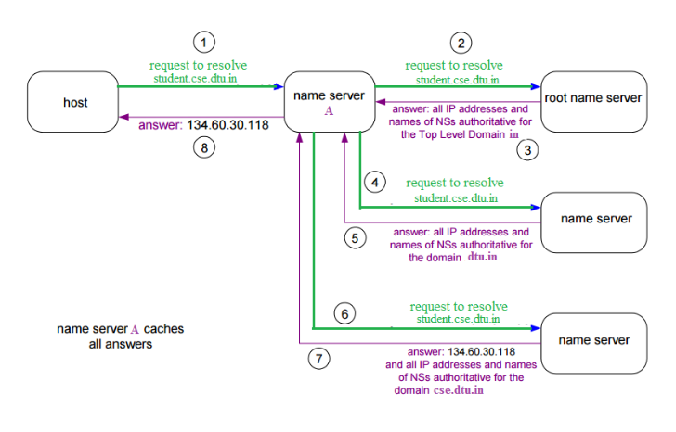

The client machine sends a request to the local name server, which , if root does not find the address in its database, sends a request to the root name server, which in turn, will route the query to an intermediate or authoritative name server. The root name server can also contain some hostName to IP address mappings . The intermediate nae server always knows who the authoritative name server is. So finally the IP address is returned to the local name server which in turn returns the IP address to the host.

**Recursive Resolution –**Here, client requires the Local Server to give either the requested mapping or an error message. A DNS Query is generated by the application program to the resolver to fetch the destination IP Address. The Query is then forward to the local DNS Server. If it knows the IP Address, it sends a response to the resolver. Assuming, it does not know the IP Address, it sends the query to the root name server.  
The root name server contains information of about at least one server of Top Level Domain. The query is then sent to the respective Top-Level Domain server. If it contains the mapping, the response is sent back to the root server and then to host’s local server. If it doesn’t contain the mapping, it should contain the IP Address of destination’s local DNS Server. The local DNS server knows the destination host’s IP Address. The information is then sent back to the top-level domain server, then to the root server and then to the host’s Local DNS Server and finally to the host.  
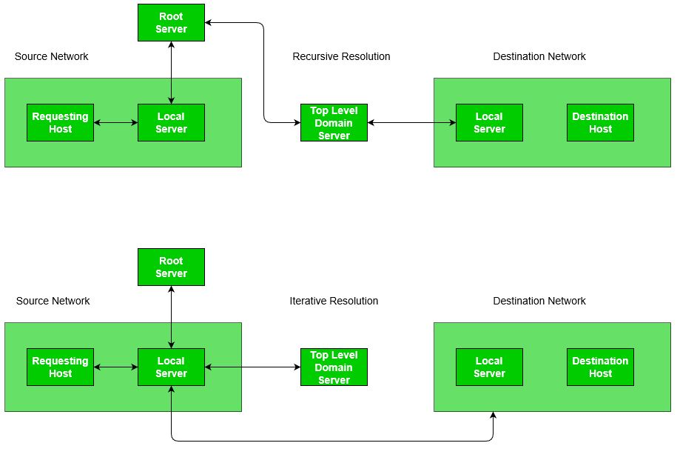

**NOTES**

**OSI Layers, Data units and Functions:**

|  |  |  |
| --- | --- | --- |
| **LAYERS** | **DATA UNITS** | **FUNCTIONS** |
| Application Layer | Data | Mail Services, Directory Services, FTAM |
| Presentation Layer | Data | Translation, Compression, Encryption/Decryption |
| Session Layer | Data | Session Establishment, Synchronization,Dialog Controller |
| Transport Layer | Segments,Datagram | Segmentation, Flow Control, Error Control, TCP/UDP |
| Network Layer | Packets | Logical Addressing, Routing, Traffic control, Fragmentation |
| Data Link Layer | Frames | Physical Addressing, Flow control,Error control,Access control |
| Physical Layer | Bits | Bit Synchronization,Bit rate control,Physical Topologies |

**Layers and their uses –**  
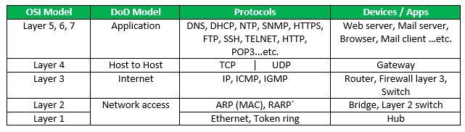

**Physical Layer**

[**Network Topologies:**](https://www.geeksforgeeks.org/network-topologies-computer-networks/)

* **Mesh Topology:**  
  In mesh topology, every device is connected to another device via particular channel.If suppose, N number of devices are connected with each other, then total number of links required to connect NC2.
* **Bus Topology:**  
  Bus topology is a network type in which every computer and network device is connected to single cable. If N devices are connected, then the number of cables required 1 which is known as backbone cable and N drop lines are required.
* **Star Topology:**  
  In star topology, all the devices are connected to a single hub through a cable. If N devices are connected to each other, then the no. of cables required N.
* **Ring Topology:**  
  In this topology, it forms a ring connecting a devices with its exactly two neighboring devices.

[**Transmission Modes:**](https://www.geeksforgeeks.org/transmission-modes-computer-networks/)

* **Simplex Mode**: the communication is unidirectional, as on a one-way street.Only one of the two devices on a link can transmit, the other can only receive.
* **Half-duplex Mode**: each station can both transmit and receive, but not at the same time.
* **Full-duplex Mode**: both stations can transmit and receive simultaneously.

[**Manchester Encoding**](https://www.geeksforgeeks.org/computer-network-manchester-encoding/): When there is a long sequence of 0s and 1s, there is a problem at the receiving end. The problem is that the synchronization is lost due to lack of transmissions.

* **NRZ-level encoding**: The polarity of signals changes when incoming siganl changes from ‘1’ to ‘0’ or from ‘0’ to ‘1’. It considers the first bit data as polarity change.
* **NRZ-Inverted/ Differential encoding**:In this, the transitions at the beginning of bit interval is equal to 1 and if there is no transition at the beginning of bit interval is equal to 0.

**Data Link Layer**

1. **Flow Control**  
   N = Sender’s Window Size. (in SR both sender and receiver window are same)  
   a = Tp /Tt

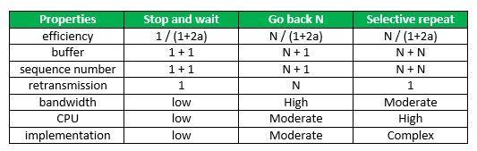

1. Sequence No. >= (Sender’s Window Size) + (Reciever’s Window Size )
2. Efficiency in TDM(polling) = Tt / (Tpoll + Tt)
3. In CSMA/CD, Tt >= 2*Tp  
   Hence, min frame length = 2*Tp*B
4. In CSMA/CD, Efficiency = 1/(1 + 6.44a)
5. [**Back-off Algorithm for CSMA/CD**](https://www.geeksforgeeks.org/back-off-algorithm-csmacd/)  
   Waiting time = back–off time  
   Let n = collision number or re-transmission serial number.  
   Then, Waiting time = K * Tslot  
   where K = [0, 2n – 1 ]
6. N = No. of stations  
   Early Token Reinsertion : Efficiency = 1/(1 + a/N)  
   Delayed Token Reinsertion : Efficiency = 1/(1 + (N+1)a/N)
7. Pure Aloha Efficiency = 18.4 %  
   Slotted Aloha Efficiency = 36.8%
8. [**Maximum data rate (channel capacity) for noiseless and noisy channels**](https://www.geeksforgeeks.org/computer-network-maximum-data-rate-channel-capacity-noiseless-noisy-channels/)
   * **Noiseless Channel : Nyquist Bit Rate**  
     BitRate = 2 * Bandwidth * log2(L)  
     where,L is the number of signal levels used to represent data.
   * **Noisy Channel : Shannon Capacity**  
     Capacity = bandwidth * log2(1 + SNR)  
     where, SNR is the signal-to-noise ratio

1. **Error Control**
   * [**Hamming Code**](https://www.geeksforgeeks.org/computer-network-hamming-code/): is a set of error-correction codes that can be used to detect and correct the errors that can occur when the data is moved or stored from the sender to the receiver.  
     **Redundant bits:**  
     2r ≥ m + r + 1  
     where, r = redundant bit, m = data bit
   * [**Framing in DLL**](https://www.geeksforgeeks.org/computer-network-framing-data-link-layer/): It provides a way for a sender to transmit a set of bits that are meaningful to the receiver.  
     **Character/Byte Stuffing:** Used when frames consist of character. If data contains ED then, byte is stuffed into data to diffentiate it from ED.  
     **Bit stuffing**: Sender stuffs a bit to break the pattern i.e. here appends a 0 in data = 0111**0**1.

**Network Layer**

[**Class Full Addressing Table**](https://www.geeksforgeeks.org/ip-addressing-introduction-and-classful-addressing/):  
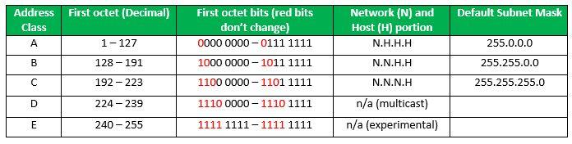

[**IPv4 header datagram**](https://www.geeksforgeeks.org/network-layer-introduction-ipv4/):  
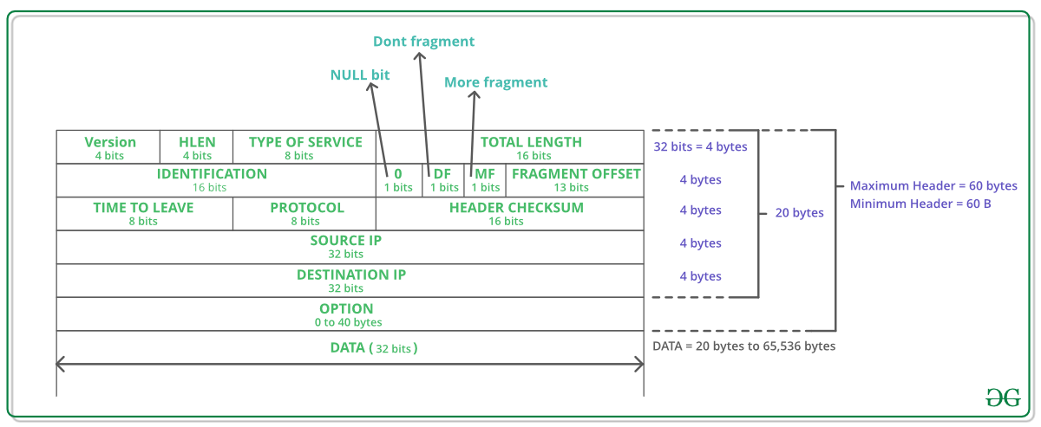

[**IP version 6 Header Format**](https://www.geeksforgeeks.org/computer-network-internet-protocol-version-6-ipv6-header/)  
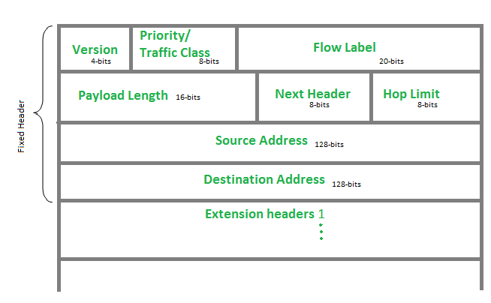

[**Internet Control Message Protocol**](https://www.geeksforgeeks.org/internet-control-message-protocol-icmp/): Since IP does not have a inbuilt mechanism for sending error and control messages. It depends on Internet Control Message Protocol(ICMP) to provide an error control.

1. Source quench message
2. Parameter problem
3. Time exceeded message
4. Destination un-reachable

[**Difference between DVR and LSR**](https://www.geeksforgeeks.org/computer-network-distance-vector-routing-vs-link-state-routing/)  
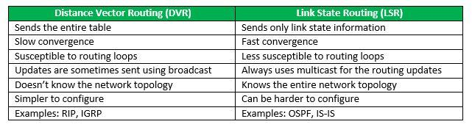

[**Open shortest path first (OSPF)**](https://www.geeksforgeeks.org/open-shortest-path-first-ospf-router-roles-configuration/): Open shortest path first (OSPF) is a link-state routing protocol which is used to find the best path between the source and the destination router using its own SPF algorithm.  
Designated Router(DR) and Backup Designated Router(BDR) election takes place in broadcast network or multi-access network.  
**Criteria for the election:**

* 1. Router having the highest router priority will be declared as DR.
  2. If there is a tie in router priority then highest router will be considered. First, highest loopback address is considered. If no loopback is configured then the highest active IP address on the interface of the router is considered.

[**Routing Information Protocol(RIP)**](https://www.geeksforgeeks.org/computer-network-routing-information-protocol-rip/): is a dynamic routing protocol which uses hop count as a routing metric to find the best path between the source and the destination network. It is a distance vector routing protocol which has AD value 120 and works on the application layer of OSI model. RIP uses port number 520.

**Hop Count**:

* 1. Hop count is the number of routers occurring in between the source and destination network. The path with the lowest hop count is considered as the best route to reach a network and therefore placed in the routing table.
  2. The maximum hop count allowed for RIP is 15 and hop count of 16 is considered as network unreachable.

**Transport Layer**

[**TCP header**](https://www.geeksforgeeks.org/tcp-services-and-segment-structure/)  
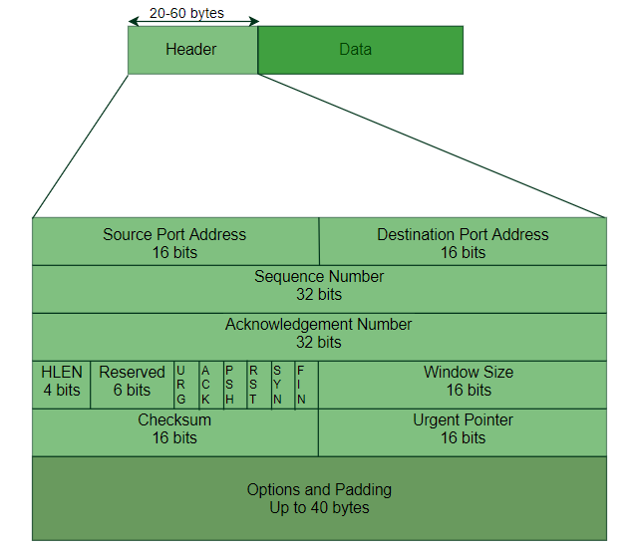

[**In TCP congestion control Algorithm**](https://www.geeksforgeeks.org/computer-network-tcp-congestion-control/)  
When Time Out Occurs Algorithm Enters Slow Start Phase  
When 3 Duplicate occurs algorithm enters congestion avoidance phase

[**TCP 3-Way Handshake Process**](https://www.geeksforgeeks.org/computer-network-tcp-3-way-handshake-process/)  
**Step 1 (SYN)** : In the first step, client wants to establish a connection with server, so it sends a segment with SYN(Synchronize Sequence Number) which informs server that client is likely to start communication and with what sequence number it starts segments with  
**Step 2 (SYN + ACK)**: Server responds to the client request with SYN-ACK signal bits set. Acknowledgement(ACK) signifies the response of segment it received and SYN signifies with what sequence number it is likely to start the segments with  
**Step 3 (ACK)** : In the final part client acknowledges the response of server and they both establish a reliable connection with which they will start eh actual data transfer.

[**UDP header**](https://www.geeksforgeeks.org/gate-cs-notes-gq/)  
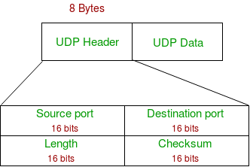

Refer the [Differences between TCP and UDP](https://www.geeksforgeeks.org/differences-between-tcp-and-udp/)

**Application Layer**

[**Domain Name Server**](https://www.geeksforgeeks.org/dns-domain-name-server/): DNS is a host name to IP address translation service. DNS is a distributed database implemented in a hierarchy of name servers. It is an application layer protocol for message exchange between clients and servers.

[**Dynamic Host Configuration Protocol(DHCP)**](https://www.geeksforgeeks.org/computer-network-dynamic-host-configuration-protocol-dhcp/) is an application layer protocol which is used to provide:  
Subnet Mask (Option 1 – e.g., 255.255.255.0)  
Router Address (Option 3 – e.g., 192.168.1.1)  
DNS Address (Option 6 – e.g., 8.8.8.8)  
Vendor Class Identifier (Option 43 – e.g., ‘unifi’ = 192.168.1.9 ##where unifi = controller)

[**Simple Network Management Protocol (SNMP)**](https://www.geeksforgeeks.org/computer-network-simple-network-management-protocol-snmp/): SNMP is an application layer protocol which uses UDP port number 161/162.SNMP is used to monitor network, detect network faults and sometimes even used to configure remote devices.

[**Simple Mail Transfer Protocol (SMTP)**](https://www.geeksforgeeks.org/simple-mail-transfer-protocol-smtp/): SMTP is an application layer protocol. The client who wants to send the mail opens a TCP connection to the SMTP server and then sends the mail across the connection. The SMTP server is always on listening mode. As soon as it listens for a TCP connection from any client, the SMTP process initiates a connection on that port (25). After successfully establishing the TCP connection the client process sends the mail instantly.

[**File Transfer Protocol (FTP)**](https://www.geeksforgeeks.org/computer-network-file-transfer-protocol-ftp/): File Transfer Protocol(FTP) is an application layer protocol which moves files between local and remote file systems. It runs on the top of TCP, like HTTP. To transfer a file, 2 TCP connections are used by FTP in parallel: control connection and data connection.

[**Hypertext Transfer Protocol (HTTP)**](https://www.geeksforgeeks.org/http-non-persistent-persistent-connection/): is an application-level protocol that uses TCP as an underlying transport and typically runs on port 80. HTTP is a stateless protocol i.e. server maintains no information about past client requests.

**Network Security**

For Symmetric Key : n*(n-1)/2 keys are required.  
For Public Key : 2*n key are required ( each node will have private and public key).

[**RSA Algorithm in Cryptography**](https://www.geeksforgeeks.org/rsa-algorithm-using-multiple-precision-arithmetic-library/)  
  
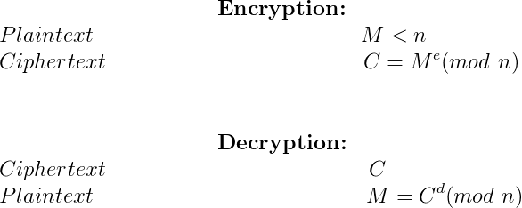

[**Deffie Hellman Key Exchange**](https://www.geeksforgeeks.org/implementation-diffie-hellman-algorithm/)  
R1 = gx mod p  
R2 = gy mod q  
Both will have same key = gxy mod p

**OS**

Commonly Asked Operating Systems Interview Questions | Set 1

**What is a process and process table? What are different states of process**  
A *process*is an instance of program in execution. For example a Web Browser is a process, a shell (or command prompt) is a process.  
The operating system is responsible for managing all the processes that are running on a computer and allocated each process a certain amount of time to use the processor. In addition, the operating system also allocates various other resources that processes will need such as computer memory or disks. To keep track of the state of all the processes, the operating system maintains a table known as the *process table*. Inside this table, every process is listed along with the resources the processes is using and the current state of the process.  
*Processes can be in one of three states: running, ready, or waiting*. The running state means that the process has all the resources it need for execution and it has been given permission by the operating system to use the processor. Only one process can be in the running state at any given time. The remaining processes are either in a waiting state (i.e., waiting for some external event to occur such as user input or a disk access) or a ready state (i.e., waiting for permission to use the processor). In a real operating system, the waiting and ready states are implemented as queues which hold the processes in these states. The animation below shows a simple representation of the life cycle of a process (Source: <http://courses.cs.vt.edu/csonline/OS/Lessons/Processes/index.html>)

**What is a Thread? What are the differences between process and thread?**  
A thread is a single sequence stream within in a process. Because threads have some of the properties of processes, they are sometimes called *lightweight processes*. Threads are popular way to improve application through parallelism. For example, in a browser, multiple tabs can be different threads. MS word uses multiple threads, one thread to format the text, other thread to process inputs, etc.  
A thread has its own program counter (PC), a register set, and a stack space. Threads are not independent of one other like processes as a result threads shares with other threads their code section, data section and OS resources like open files and signals. See <http://www.personal.kent.edu/~rmuhamma/OpSystems/Myos/threads.htm> for more details.

**Process vs Thread?**

The primary difference is that threads within the same process run in a shared memory space, while processes run in separate memory spaces.

Threads are not independent of one another like processes are, and as a result threads share with other threads their code section, data section, and OS resources (like open files and signals). But, like process, a thread has its own program counter (PC), register set, and stack space.

**Advantages of Thread over Process**

1. Responsiveness: If the process is divided into multiple threads, if one thread completes its execution, then its output can be immediately returned.

2. Faster context switch: Context switch time between threads is lower compared to process context switch. Process context switching requires more overhead from the CPU.

3. Effective utilization of multiprocessor system: If we have multiple threads in a single process, then we can schedule multiple threads on multiple processor. This will make process execution faster.

4. Resource sharing: Resources like code, data, and files can be shared among all threads within a process.

Note: stack and registers can’t be shared among the threads. Each thread has its own stack and registers.

5. Communication: Communication between multiple threads is easier, as the threads shares common address space. while in process we have to follow some specific communication technique for communication between two process.

6. Enhanced throughput of the system: If a process is divided into multiple threads, and each thread function is considered as one job, then the number of jobs completed per unit of time is increased, thus increasing the throughput of the system.

**Types of Threads**

There are two types of threads.

User Level Thread

Kernel Level Thread

**What is deadlock?**  
Deadlock is a situation when two or more processes wait for each other to finish and none of them ever finish.  Consider an example when two trains are coming toward each other on same track and there is only one track, none of the trains can move once they are in front of each other.  Similar situation occurs in operating systems when there are two or more processes hold some resources and wait for resources held by other(s).

**What are the necessary conditions for deadlock?**  
*Mutual Exclusion:* There is a resource that cannot be shared.  
*Hold and Wait:*A process is holding at least one resource and waiting for another resource which is with some other process.  
*No Preemption:* The operating system is not allowed to take a resource back from a process until process gives it back.  
*Circular Wait:*A set of processes are waiting for each other in circular form.

**What is Virtual Memory? How is it implemented?**  
Virtual memory creates an illusion that each user has one or more contiguous address spaces, each beginning at address zero. The sizes of such virtual address spaces is generally very high.  
The idea of virtual memory is to use disk space to extend the RAM. Running processes don’t need to care whether the memory is from RAM or disk. The illusion of such a large amount of memory is created by subdividing the virtual memory into smaller pieces, which can be loaded into physical memory whenever they are needed by a process.

**What is Thrashing?**  
Thrashing is a situation when the performance of a computer degrades or collapses. Thrashing occurs when a system spends more time processing page faults than executing transactions. While processing page faults is necessary to in order to appreciate the benefits of virtual memory, thrashing has a negative affect on the system. As the page fault rate increases, more transactions need processing from the paging device. The queue at the paging device increases, resulting in increased service time for a page fault (Source: h[ttp://cs.gmu.edu/cne/modules/vm/blue/thrash.html](http://cs.gmu.edu/cne/modules/vm/blue/thrash.html))

**What is Belady’s Anomaly?**  
Bélády’s anomaly is an anomaly with some page replacement policies where increasing the number of page frames results in an increase in the number of page faults. It occurs with First in First Out page replacement is used. See [the wiki page](http://en.wikipedia.org/wiki/B%C3%A9l%C3%A1dy's_anomaly)for an example and more details.

**Differences between mutex and semaphore?**

**Using Mutex:**

A mutex provides mutual exclusion, either producer or consumer can have the key (mutex) and proceed with their work. As long as the buffer is filled by producer, the consumer needs to wait, and vice versa.

At any point of time, only one thread can work with the *entire* buffer. The concept can be generalized using semaphore.

**Using Semaphore:**

A semaphore is a generalized mutex. In lieu of single buffer, we can split the 4 KB buffer into four 1 KB buffers (identical resources). A semaphore can be associated with these four buffers. The consumer and producer can work on different buffers at the same time.

**Misconception:**

There is an ambiguity between *binary semaphore* and *mutex*. We might have come across that a mutex is binary semaphore. *But they are not*! The purpose of mutex and semaphore are different. May be, due to similarity in their implementation a mutex would be referred as binary semaphore.

Strictly speaking, a mutex is **locking mechanism**used to synchronize access to a resource. Only one task (can be a thread or process based on OS abstraction) can acquire the mutex. It means there is ownership associated with mutex, and only the owner can release the lock (mutex).

Semaphore is **signaling mechanism** (“I am done, you can carry on” kind of signal). For example, if you are listening songs (assume it as one task) on your mobile and at the same time your friend calls you, an interrupt is triggered upon which an interrupt service routine (ISR) signals the call processing task to wakeup.

**Zombie Process:**

A process which has finished the execution but still has an entry in the process table to report to its parent process is known as a zombie process. A child process always first becomes a zombie before being removed from the process table. The parent process reads the exit status of the child process which reaps off the child process entry from the process table.

In the following code, the child finishes its execution using exit() system call while the parent sleeps for 50 seconds, hence doesn’t call [wait()](https://en.wikipedia.org/wiki/Wait_%28system_call%29) and the child process’s entry still exists in the process table.

|  |
| --- |
| // A C program to demonstrate Zombie Process.  // Child becomes Zombie as parent is sleeping  // when child process exits.  #include <stdlib.h>  #include <sys/types.h>  #include <unistd.h>  int main()  {  // Fork returns process id  // in parent process  pid_t child_pid = fork();    // Parent process  if (child_pid > 0)  sleep(50);    // Child process  else  exit(0);    return 0;  } |

**Orphan Process:**

A process whose parent process no more exists i.e. either finished or terminated without waiting for its child process to terminate is called an orphan process.

In the following code, parent finishes execution and exits while the child process is still executing and is called an orphan process now.

However, the orphan process is soon adopted by init process, once its parent process dies.

|  |
| --- |
| // A C program to demonstrate Orphan Process.  // Parent process finishes execution while the  // child process is running. The child process  // becomes orphan.  #include<stdio.h>  #include <sys/types.h>  #include <unistd.h>    int main()  {  // Create a child process  int pid = fork();    if (pid > 0)  printf("in parent process");    // Note that pid is 0 in child process  // and negative if fork() fails  else if (pid == 0)  {  sleep(30);  printf("in child process");  }    return 0;  } |

**NOTES**

**Operating Systems:**It is the interface between the user and the computer hardware.

[**Types of Operating System (OS):**](https://www.geeksforgeeks.org/operating-system-types-operating-systems-awaiting-author/)

1. **Batch OS –** A set of similar jobs are stored in the main memory for execution. A job gets assigned to the CPU, only when the execution of the previous job completes.
2. **Multiprogramming OS –** The main memory consists of jobs waiting for CPU time. The OS selects one of the processes and assigns it to the CPU. Whenever the executing process needs to wait for any other operation (like I/O), the OS selects another process from the job queue and assigns it to the CPU. This way, the CPU is never kept idle and the user gets the flavor of getting multiple tasks done at once.
3. **Multitasking OS –** Multitasking OS combines the benefits of Multiprogramming OS and CPU scheduling to perform quick switches between jobs. The switch is so quick that the user can interact with each program as it runs
4. **Time Sharing OS –** Time-sharing systems require interaction with the user to instruct the OS to perform various tasks. The OS responds with an output. The instructions are usually given through an input device like the keyboard.
5. **Real Time OS –** Real-Time OS are usually built for dedicated systems to accomplish a specific set of tasks within deadlines.

[**Threads:**](https://www.geeksforgeeks.org/operating-system-threads-types/)  
A thread is a lightweight process and forms the basic unit of CPU utilization. A process can perform more than one task at the same time by including multiple threads.

* A thread has its own program counter, register set, and stack
* A thread shares resources with other threads of the same process the code section, the data section, files and signals.

A new thread, or a child process of a given process, can be introduced by using the fork() system call. A process with n fork() system calls generates 2n – 1 child processes.  
There are two types of threads:

* User threads
* Kernel threads

*Example:* Java thread, POSIX threads.Example : Window Solaris.

|  |  |
| --- | --- |
| **USER LEVEL THREAD** | **KERNEL LEVEL THREAD** |
| User threads are implemented by users. | kernel threads are implemented by OS. |
| OS doesn’t recognize user level threads. | Kernel threads are recognized by OS. |
| Implementation of User threads is easy. | Implementation of Kernel thread is complicated. |
| Context switch time is less. | Context switch time is more. |
| Context switch requires no hardware support. | Hardware support is needed. |
| If one user level thread performs blocking operation then entire process will be blocked. | If one kernel thread performs blocking operation then another thread can continue execution. |

[**Process:**](https://www.geeksforgeeks.org/gate-notes-operating-system-process-management-introduction/)  
A process is a program under execution. The value of program counter (PC) indicates the address of the next instruction of the process being executed. Each process is represented by a Process Control Block (PCB).

[**Process Scheduling:**](https://www.geeksforgeeks.org/gate-notes-operating-system-process-scheduling/) Below are different times with respect to a process.

1. **Arrival Time –** Time at which the process arrives in the ready queue.
2. **Completion Time –** Time at which process completes its execution.
3. **Burst Time –** Time required by a process for CPU execution.
4. **Turn Around Time –** Time Difference between completion time and arrival time.

Turn Around Time = Completion Time - Arrival Time

1. **Waiting Time (WT) –** Time Difference between turn around time and burst time.

Waiting Time = Turn Around Time - Burst Time

**Why do we need scheduling?**  
A typical process involves both I/O time and CPU time. In a uniprogramming system like MS-DOS, time spent waiting for I/O is wasted and CPU is free during this time. In multiprogramming systems, one process can use CPU while another is waiting for I/O. This is possible only with process scheduling.

**Objectives of Process Scheduling Algorithm:**

* Max CPU utilization (Keep CPU as busy as possible)
* Fair allocation of CPU.
* Max throughput (Number of processes that complete their execution per time unit)
* Min turnaround time (Time taken by a process to finish execution)
* Min waiting time (Time for which a process waits in ready queue)
* Min response time (Time when a process produces first response)

**Different Scheduling Algorithms:**

1. [**First Come First Serve (FCFS)**](https://www.geeksforgeeks.org/program-fcfs-scheduling-set-1/): Simplest scheduling algorithm that schedules according to arrival times of processes.
2. [**Shortest Job First (SJF)**](https://www.geeksforgeeks.org/program-shortest-job-first-sjf-scheduling-set-1-non-preemptive/): Process which have the shortest burst time are scheduled first.
3. [**Shortest Remaining Time First (SRTF)**](https://www.geeksforgeeks.org/program-shortest-job-first-scheduling-set-2srtf-make-changesdoneplease-review/): It is preemptive mode of SJF algorithm in which jobs are scheduled according to the shortest remaining time.
4. [**Round Robin (RR) Scheduling**](https://www.geeksforgeeks.org/program-round-robin-scheduling-set-1/): Each process is assigned a fixed time, in cyclic way.
5. [**Priority Based scheduling (Non Preemptive)**](https://www.geeksforgeeks.org/program-priority-scheduling-set-1/): In this scheduling, processes are scheduled according to their priorities, i.e., highest priority process is schedule first. If priorities of two processes match, then scheduling is according to the arrival time.
6. [**Highest Response Ratio Next (HRRN)**](https://www.geeksforgeeks.org/operating-system-highest-response-ratio-next-hrrn-scheduling/): In this scheduling, processes with highest response ratio is scheduled. This algorithm avoids starvation.

Response Ratio = (Waiting Time + Burst time) / Burst time

1. [**Multilevel Queue Scheduling (MLQ)**](https://www.geeksforgeeks.org/operating-system-multilevel-queue-scheduling/): According to the priority of process, processes are placed in the different queues. Generally high priority process are placed in the top level queue. Only after completion of processes from top level queue, lower level queued processes are scheduled.
2. [**Multi level Feedback Queue (MLFQ) Scheduling**](https://www.geeksforgeeks.org/multilevel-feedback-queue-scheduling/): It allows the process to move in between queues. The idea is to separate processes according to the characteristics of their CPU bursts. If a process uses too much CPU time, it is moved to a lower-priority queue.

**Some useful facts about Scheduling Algorithms:**

1. FCFS can cause long waiting times, especially when the first job takes too much CPU time.
2. Both SJF and Shortest Remaining time first algorithms may cause starvation. Consider a situation when a long process is there in the ready queue and shorter processes keep coming.
3. If time quantum for Round Robin scheduling is very large, then it behaves same as FCFS scheduling.
4. SJF is optimal in terms of average waiting time for a given set of processes. SJF gives minimum average waiting time, but problems with SJF is how to know/predict the time of next job.

**The Critical Section Problem:**

1. **Critical Section –** The portion of the code in the program where shared variables are accessed and/or updated.
2. **Remainder Section –** The remaining portion of the program excluding the Critical Section.
3. **Race around Condition –** The final output of the code depends on the order in which the variables are accessed. This is termed as the race around condition.

A solution for the critical section problem must satisfy the following three conditions:

1. **Mutual Exclusion –** If a process Pi is executing in its critical section, then no other process is allowed to enter into the critical section.
2. **Progress –** If no process is executing in the critical section, then the decision of a process to enter a critical section cannot be made by any other process that is executing in its remainder section. The selection of the process cannot be postponed indefinitely.
3. **Bounded Waiting –** There exists a bound on the number of times other processes can enter into the critical section after a process has made request to access the critical section and before the requested is granted.

**Synchronization Tools:**  
A **Semaphore** is an integer variable that is accessed only through two atomic operations, wait () and signal (). An atomic operation is executed in a single CPU time slice without any pre-emption. Semaphores are of two types:

1. **Counting Semaphore –** A counting semaphore is an integer variable whose value can range over an unrestricted domain.
2. **Mutex –** Binary Semaphores are called Mutex. These can have only two values, 0 or 1. The operations wait () and signal () operate on these in a similar fashion.

[**Deadlock**](https://www.geeksforgeeks.org/operating-system-process-management-deadlock-introduction/):  
A situation where a set of processes are blocked because each process is holding a resource and waiting for another resource acquired by some other process. Deadlock can arise if following four conditions hold simultaneously (Necessary Conditions):

1. **Mutual Exclusion –** One or more than one resource are non-sharable (Only one process can use at a time).
2. **Hold and Wait –** A process is holding at least one resource and waiting for resources.
3. **No Preemption –** A resource cannot be taken from a process unless the process releases the resource.
4. **Circular Wait –** A set of processes are waiting for each other in circular form.

**Methods for handling deadlock:** There are three ways to handle deadlock

1. [**Deadlock prevention or avoidance**](https://www.geeksforgeeks.org/deadlock-prevention/): The idea is to not let the system into deadlock state.

**Deadlock Prevention**

We can prevent Deadlock by eliminating any of the above four conditions.

**Eliminate Mutual Exclusion**  
It is not possible to dis-satisfy the mutual exclusion because some resources, such as the tap drive and printer, are inherently non-shareable.

**Eliminate Hold and wait**

1. Allocate all required resources to the process before the start of its execution, this way hold and wait condition is eliminated but it will lead to low device utilization. for example, if a process requires printer at a later time and we have allocated printer before the start of its execution printer will remain blocked till it has completed its execution.
2. The process will make a new request for resources after releasing the current set of resources. This solution may lead to starvation.

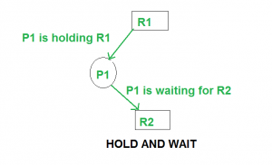

**Eliminate No Preemption**  
Preempt resources from the process when resources required by other high priority processes.

**Eliminate Circular Wait**  
Each resource will be assigned with a numerical number. A process can request the resources increasing/decreasing. order of numbering.  
For Example, if P1 process is allocated R5 resources, now next time if P1 ask for R4, R3 lesser than R5 such request will not be granted, only request for resources more than R5 will be granted.

**Deadlock Avoidance**

Deadlock avoidance can be done with Banker’s Algorithm.

**Banker’s Algorithm**

Bankers’s Algorithm is resource allocation and deadlock avoidance algorithm which test all the request made by processes for resources, it checks for the safe state, if after granting request system remains in the safe state it allows the request and if there is no safe state it doesn’t allow the request made by the process.

**Inputs to Banker’s Algorithm:**

1. Max need of resources by each process.
2. Currently allocated resources by each process.
3. Max free available resources in the system.

**The request will only be granted under the below condition:**

1. If the request made by the process is less than equal to max need to that process.
2. If the request made by the process is less than equal to the freely available resource in the system.

**Example:**

Total resources in system:

A B C D

6 5 7 6

Available system resources are:

A B C D

3 1 1 2

Processes (currently allocated resources):

A B C D

P1 1 2 2 1

P2 1 0 3 3

P3 1 2 1 0

Processes (maximum resources):

A B C D

P1 3 3 2 2

P2 1 2 3 4

P3 1 3 5 0

Need = maximum resources - currently allocated resources.

Processes (need resources):

A B C D

P1 2 1 0 1

P2 0 2 0 1

P3 0 1 4 0

**Note:**Deadlock prevention is more strict that Deadlock Avoidance.

1. [**Deadlock detection and recovery**](https://www.geeksforgeeks.org/deadlock-detection-recovery/) : Let deadlock occur, then do preemption to handle it once occurred.

**Deadlock Detection**

1. If resources have single instance:  
   In this case for Deadlock detection we can run an algorithm to check for cycle in the Resource Allocation Graph. Presence of cycle in the graph is the sufficient condition for deadlock.  
   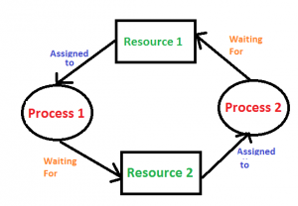

In the above diagram, resource 1 and resource 2 have single instances. There is a cycle R1 → P1 → R2 → P2. So, Deadlock is Confirmed.

1. If there are multiple instances of resources:  
   Detection of the cycle is necessary but not sufficient condition for deadlock detection, in this case, the system may or may not be in deadlock varies according to different situations.

**Deadlock Recovery**  
A traditional operating system such as Windows doesn’t deal with deadlock recovery as it is time and space consuming process. Real-time operating systems use Deadlock recovery.

**Recovery method**

1. **Killing the process:** killing all the process involved in the deadlock. Killing process one by one. After killing each process check for deadlock again keep repeating the process till system recover from deadlock.
2. **Resource Preemption:** Resources are preempted from the processes involved in the deadlock, preempted resources are allocated to other processes so that there is a possibility of recovering the system from deadlock. In this case, the system goes into starvation.
3. **Ignore the problem all together –** : If deadlock is very rare, then let it happen and reboot the system. This is the approach that both Windows and UNIX take.

[**Banker’s Algorithm:**](https://www.geeksforgeeks.org/operating-system-bankers-algorithm/)  
This algorithm handles multiple instances of the same resource.

**Memory Management:**  
These techniques allow the memory to be shared among multiple processes.

* **Overlays –** The memory should contain only those instructions and data that are required at a given time.
* **Swapping –** In multiprogramming, the instructions that have used the time slice are swapped out from the memory.

[**Memory Management Techniques:**](https://www.geeksforgeeks.org/operating-system-memory-management-partition-allocation-method/)

**(a) Single Partition Allocation Schemes –**  
The memory is divided into two parts. One part is kept to be used by the OS and the other is kept to be used by the users.

**(b) Multiple Partition Schemes –**

1. **Fixed Partition –** The memory is divided into fixed size partitions.
2. **Variable Partition –** The memory is divided into variable sized partitions.

Variable partition allocation schemes:

1. **First Fit –** The arriving process is allotted the first hole of memory in which it fits completely.
2. **Best Fit –** The arriving process is allotted the hole of memory in which it fits the best by leaving the minimum memory empty.
3. **Worst Fit –** The arriving process is allotted the hole of memory in which it leaves the maximum gap.

**Note:**

* Best fit does not necessarily give the best results for memory allocation.
* The cause of external fragmentation is the condition in Fixed partitioning and Variable partitioning saying that entire process should be allocated in a contiguous memory location. Therefore **Paging** is used.

1. **Paging –**  
   The physical memory is divided into equal sized frames. The main memory is divided into fixed size pages. The size of a physical memory frame is equal to the size of a virtual memory frame.
2. **Segmentation –**  
   Segmentation is implemented to give users view of memory. The logical address space is a collection of segments. Segmentation can be implemented with or without the use of paging.

[**Page Fault:**](https://www.geeksforgeeks.org/operating-system-page-fault-handling/)  
A page fault is a type of interrupt, raised by the hardware when a running program accesses a memory page that is mapped into the virtual address space, but not loaded in physical memory.

[**Page Replacement Algorithms:**](https://www.geeksforgeeks.org/page-replacement-algorithms-in-operating-systems/)

1. **First In First Out (FIFO) –**  
   This is the simplest page replacement algorithm. In this algorithm, operating system keeps track of all pages in the memory in a queue, oldest page is in the front of the queue. When a page needs to be replaced page in the front of the queue is selected for removal.

For example, consider page reference string 1, 3, 0, 3, 5, 6 and 3 page slots. Initially, all slots are empty, so when 1, 3, 0 came they are allocated to the empty slots —> 3 Page Faults. When 3 comes, it is already in  memory so —> 0 Page Faults. Then 5 comes, it is not available in  memory so it replaces the oldest page slot i.e 1. —> 1 Page Fault. Finally, 6 comes,  it is also not available in memory so it replaces the oldest page slot i.e 3 —> 1 Page Fault.

**Belady’s anomaly:**  
Belady’s anomaly proves that it is possible to have more page faults when increasing the number of page frames while using the First in First Out (FIFO) page replacement algorithm.  For example, if we consider reference string      3     2     1     0     3     2     4     3     2     1     0     4 and 3 slots, we get 9 total page faults, but if we increase slots to 4, we get 10 page faults.

1. **Optimal Page replacement –**  
   In this algorithm, pages are replaced which are not used for the longest duration of time in the future.

Let us consider page reference string 7 0 1 2 0 3 0 4 2 3 0 3 2 and 4 page slots. Initially, all slots are empty, so when 7 0 1 2 are allocated to the empty slots —> 4 Page faults. 0 is already there so —> 0 Page fault. When 3 came it will take the place of 7 because it is not used for the longest duration of time in the future.—> 1 Page fault. 0 is already there so —> 0 Page fault. 4 will takes place of 1 —> 1 Page Fault. Now for the further page reference string —> 0 Page fault because they are already available in the memory.

Optimal page replacement is perfect, but not possible in practice as an operating system cannot know future requests. The use of Optimal Page replacement is to set up a benchmark so that other replacement algorithms can be analyzed against it.

1. **Least Recently Used (LRU) –**  
   In this algorithm, the page will be replaced which is least recently used.

Let say the page reference string 7 0 1 2 0 3 0 4 2 3 0 3 2 . Initially, we have 4-page slots empty. Initially, all slots are empty, so when 7 0 1 2 are allocated to the empty slots —> 4 Page faults. 0 is already their so —> 0 Page fault. When 3 came it will take the place of 7 because it is least recently used —> 1 Page fault. 0 is already in memory so —> 0 Page fault. 4 will takes place of 1 —> 1 Page Fault. Now for the further page reference string —>**0 Page fault** because they are already available in the memory.

[**File System**](https://www.geeksforgeeks.org/file-system-operating-systems/): A file is a collection of related information that is recorded on secondary storage. Or file is a collection of logically related entities.

[**File Directories**](https://www.geeksforgeeks.org/file-system-operating-systems/): Collection of files is a file directory. The directory contains information about the files, including attributes, location and ownership. Much of this information, especially that is concerned with storage, is managed by the operating system.

* 1. **SINGLE-LEVEL DIRECTORY**: In this a single directory is maintained for all the users
  2. **TWO-LEVEL DIRECTORY**: Due to two levels there is a path name for every file to locate that file.
  3. **TREE-STRUCTURED DIRECTORY**: Directory is maintained in the form of a tree. Searching is efficient and also there is grouping capability.

[**File Allocation Methods**](https://www.geeksforgeeks.org/file-system-operating-systems/):

* 1. **Continuous Allocation**: A single continuous set of blocks is allocated to a file at the time of file creation.
  2. **Linked Allocation(Non-contiguous allocation)**: Allocation is on an individual block basis. Each block contains a pointer to the next block in the chain.
  3. **Indexed Allocation**: It addresses many of the problems of contiguous and chained allocation. In this case, the file allocation table contains a separate one-level index for each file

[**Disk Scheduling**](https://www.geeksforgeeks.org/disk-scheduling-algorithms/):  
Disk scheduling is done by operating systems to schedule I/O requests arriving for disk. Disk scheduling is also known as I/O scheduling.

* 1. **Seek Time:** Seek time is the time taken to locate the disk arm to a specified track where the data is to be read or write.
  2. **Rotational Latency:**Rotational Latency is the time taken by the desired sector of disk to rotate into a position so that it can access the read/write heads.
  3. **Transfer Time:** Transfer time is the time to transfer the data. It depends on the rotating speed of the disk and number of bytes to be transferred.
  4. **Disk Access Time:** Seek Time + Rotational Latency + Transfer Time
  5. **Disk Response Time:**Response Time is the average of time spent by a request waiting to perform its I/O operation. Average Response time is the response time of the all requests.

[**Disk Scheduling Algorithms**](https://www.geeksforgeeks.org/disk-scheduling-algorithms/):

* 1. **FCFS:** FCFS is the simplest of all the Disk Scheduling Algorithms. In FCFS, the requests are addressed in the order they arrive in the disk queue.
  2. **SSTF:**In SSTF (Shortest Seek Time First), requests having shortest seek time are executed first. So, the seek time of every request is calculated in advance in a queue and then they are scheduled according to their calculated seek time. As a result, the request near the disk arm will get executed first.
  3. **SCAN:** In SCAN algorithm the disk arm moves into a particular direction and services the requests coming in its path and after reaching the end of the disk, it reverses its direction and again services the request arriving in its path. So, this algorithm works like an elevator and hence also known as elevator algorithm.
  4. **CSCAN:** In SCAN algorithm, the disk arm again scans the path that has been scanned, after reversing its direction. So, it may be possible that too many requests are waiting at the other end or there may be zero or few requests pending at the scanned area.
  5. **LOOK:**It is similar to the SCAN disk scheduling algorithm except for the difference that the disk arm in spite of going to the end of the disk goes only to the last request to be serviced in front of the head and then reverses its direction from there only. Thus it prevents the extra delay which occurred due to unnecessary traversal to the end of the disk.
  6. **CLOOK:**As LOOK is similar to SCAN algorithm, in a similar way, CLOOK is similar to CSCAN disk scheduling algorithm. In CLOOK, the disk arm in spite of going to the end goes only to the last request to be serviced in front of the head and then from there goes to the other end’s last request. Thus, it also prevents the extra delay which occurred due to unnecessary traversal to the end of the disk.

**COMPILER DESIGN**

[**Phases of Compiler**](https://www.geeksforgeeks.org/compiler-design-phases-compiler/):  
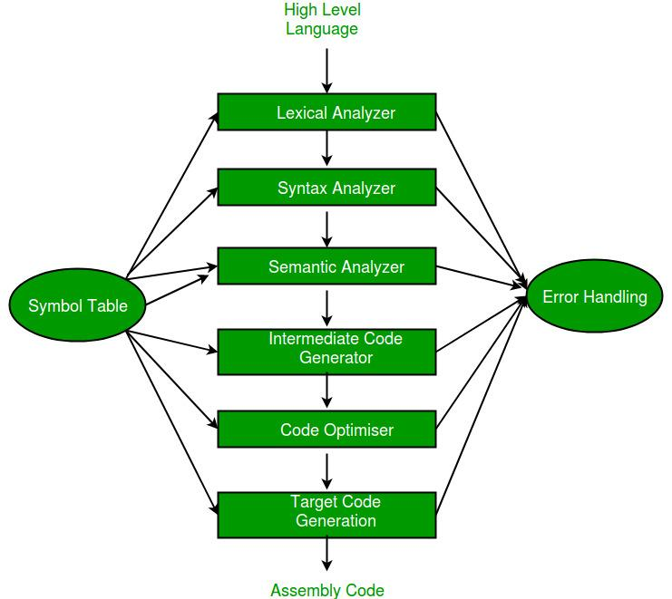

[**Symbol Table**](https://www.geeksforgeeks.org/symbol-table-compiler/) : It is a data structure being used and maintained by the compiler, consists all the identifier’s name along with their types. It helps the compiler to function smoothly by finding the identifiers quickly.

1. **Lexical Analysis** : Lexical analyzer reads a source program character by character to produce tokens. Tokens can be identifiers, keywords, operators, separators etc.
2. **Syntax Analysis** : Syntax analyzer is also known as parser. It constructs the parse tree. It takes all the tokens one by one and uses Context Free Grammar to construct the parse tree.
3. **Semantic Analyzer** : It verifies the parse tree, whether it’s meaningful or not. It furthermore produces a verified parse tree.
4. **Intermediate Code Generator**: It generates intermediate code, that is a form which can be readily executed by machine We have many popular intermediate codes.
5. **Code Optimizer** : It transforms the code so that it consumes fewer resources and produces more speed.
6. **Target Code Generator** : The main purpose of Target Code generator is to write a code that the machine can understand. The output is dependent on the type of assembler.

[**Error handling**](https://www.geeksforgeeks.org/error-handling-compiler-design/) :  
The tasks of the Error Handling process are to detect each error, report it to the user, and then make some recover strategy and implement them to handle error. An Error is the blank entries in the symbol table. There are two types of error :

**Run-Time Error** : A run-time error is an error which takes place during the execution of a program, and usually happens because of adverse system parameters or invalid input data.

**Compile-Time Error**: Compile-time errors rises at compile time, before execution of the program.

1. **Lexical :**This includes misspellings of identifiers, keywords or operators.
2. **Syntactical :**missing semicolon or unbalanced parenthesis.
3. **Semantical :**incompatible value assignment or type mismatches between operator and operand.
4. **Logical :**code not reachable, infinite loop.

**Left Recursion** : The grammar : A -> Aa | a is left recursive. Top down parsing techniques cannot handle left recursive grammar so we convert left recursion into right recursion.  
Left recursion elimination : A -> Aa | a ⇒ A -> aA’  
A’ -> aA’ | a

**Left Factoring** : If a grammar has common prefixes in r.h.s of nonterminal then suh grammar needs to be left factored by eliminating common prefixes as follows :  
A -> ab1 | ac2 ⇒ A -> A -> aA’  
A’ -> A -> b1 | c2

[**FIRST(A)**](https://www.geeksforgeeks.org/compiler-design-first-in-syntax-analysis/) is a set of the terminal symbols which occur as first symbols in string derived from A

[**FOLLOW(A)**](https://www.geeksforgeeks.org/compiler-design-follow-set-in-syntax-analysis/) is the set of terminals which occur immediately after the nonterminal A in the strings derived from the starting symbol.

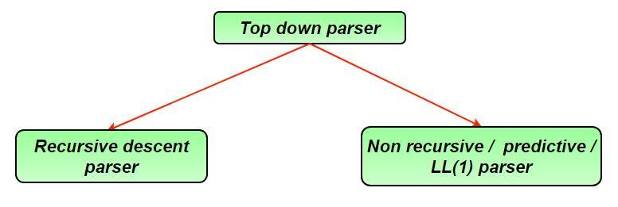

**LL(1) Parser** : LL(1) grammar is unambiguous, left factored and non left recursive.  
To check whether a grammar is LL(1) or not :  
1. If A -> B1 | C2 ⇒ { FIRST(B1) ∩ FIRST(C2 ) = φ }  
2. If A -> B | ∈ ⇒ { FIRST(B) ∩ FOLLOW(A) = φ }

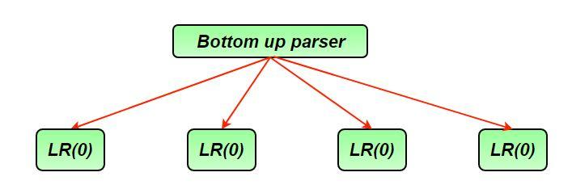

**LR(0) Parser** : Closure() and goto() functions are used to create canonical collection of LR items.  
Conflicts in LR(0) parser :

1. **Shift Reduce (SR) conflict :** when the same state in DFA contains both shift and reduce items. A -> B . xC (shifting) B -> a. (reduced)

2. **Reduced Reduced (RR) conflict :** two reductions in same state of DFA A -> a. (reduced) B -> b. (reduced)

**SLR Parser**: It is powerful than LR(0).  
Ever LR(0) is SLR but every SLR need not be LR(0).  
Conflicts in SLR  
1. SR conflict : A -> B . xC (shifting) B -> a. (reduced) if FOLLOW(B) ∩ {x} ≠ φ  
2. RR conflict : A -> a. (reduced) B -> b. (reduced) if FOLLOW(A) ∩ FOLLOW(B) ≠ φ

**CLR Parser** : It is same as SLR parser except that the reduced entries in CLR parsing table go only in the FOLLOW of the l.h.s nonterminal.

**LALR Parser** : It is constructed from CLR parser, if two states having same productions but may contain different lookaheads, those two states of CLR are combined into single state in LALR.  
Every LALR grammar is CLR but every CLR grammar need not be LALR.  
 **Parsers Comparison :**  
LR(0) ⊂ SLR ⊂ LALR ⊂ CLR  
LL(1) ⊂ LALR ⊂ CLR  
If number of states LR(0) = n1, number of states SLR = n2, number of states LALR = n3, number of states CLR = n4 then, n1 = n2 = n3 <= n4

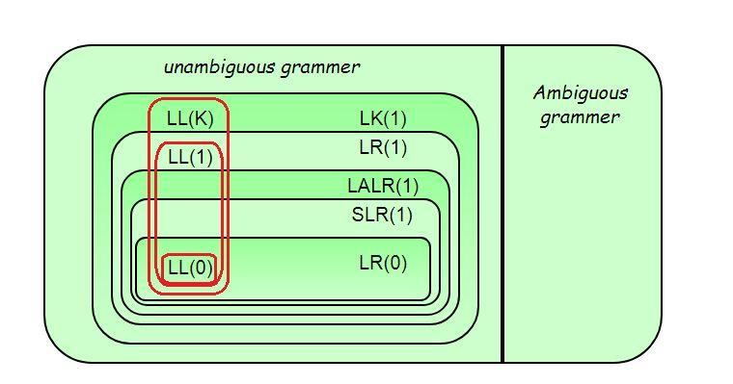

[**Syntax Directed Translation**](https://www.geeksforgeeks.org/compiler-design-syntax-directed-translation/): Syntax Directed Translation are augmented rules to the grammar that facilitate semantic analysis.  
Eg – S -> AB {print (*)}  
A -> a {print (1)}  
B -> b {print (2)}

**Synthesized Attribute**: attribute whose value is evaluated in terms of attribute values of its children.

**Inherited Attribute** : attribute whose value is evaluated in terms of attribute values of siblings or parents.

[**S-attributed SDT**](https://www.geeksforgeeks.org/s-attributed-and-l-attributed-sdts-in-syntax-directed-translation/): If an SDT uses only synthesized attributes, it is called as S-attributed SDT. S-attributed SDTs are evaluated in bottom-up parsing, as the values of the parent nodes depend upon the values of the child nodes.

[**L-attributed SDT**](https://www.geeksforgeeks.org/s-attributed-and-l-attributed-sdts-in-syntax-directed-translation/): If an SDT uses either synthesized attributes or inherited attributes with a restriction that it can inherit values from left siblings only, it is called as L-attributed SDT. Attributes in L-attributed SDTs are evaluated by depth-first and left-to-right parsing manner.

**Activation Record**: Information needed by a single execution of a procedure is managed using a contiguous block of storage called activation record. An activation record is allocated when a procedure is entered and it is deallocated when that procedure is exited.

[**Intermediate Code**](https://www.geeksforgeeks.org/intermediate-code-generation-in-compiler-design/): They are machine independent codes. Syntax trees, postfix notation, 3-address codes can be used to represent intermediate code.

[**Three address code**](https://www.geeksforgeeks.org/three-address-code-compiler/):  
1. Quadruples (4 fields : operator, operand1, operand2, result)  
2. Triplets (3 fields : operator, operand1, operand2)  
3. Indirect triples

[**Code Optimization**](https://www.geeksforgeeks.org/compiler-design-code-optimization/):

Types of machine independent optimizations –  
1. **Loop optimizations** :

* Code motion : reduce the evaluation frequency of expression.
* Loop unrolling : to execute less number of iterations
* Loop jamming : combine body of two loops whenever they are sharing same index.

2. **Constant folding** : replacing the value of constants during compilation  
3. **Constant propagation** : replacing the value of an expression during compile time.  
4. **Strength reduction** : replacing costly operators by simple operators.

**SYSTEM DESIGN**

# Design Scalable System like Instagram

**1- WHAT IS INSTAGRAM?**

Instagram is one of the best social media platforms in today’s world. Most of the people use the Instagram every day effectively and continuously. This causes that Instagram is under heavy-traffic. As you know, heavy-traffic means that there are too many incoming requests to the system and system should respond all these requests under reliability, availability and minimum latency.

As you know Instagram is a social media platform that ensures users to upload, share, view, comment pictures via this platform. Additionally, you can follow other users. If you are using Instagram, you can realize that user’s timeline is one the best and important topic for Instagram because every user meet this system in its timeline and timeline creation time is so important under this conditions.

**2- REQUIREMENTS AND GOALS OF THE SYSTEM**

As you know, if you need to design your design carefully, you should focus three requirement topics which are functional, nonfunctional, extended requirements.

**a-) Functional Requirements**

   – Users can register the system.  
   – Users can log in and log out the system.  
   – Users can share, download, view pictures of their pictures or other user’s pictures.  
   – Users can follow other users.  
   – Users can share (upload) pictures when they register and log into the system.  
   – Users can view (download) pictures when other users allow that their pictures can be viewed publicly.  
   – Users can view hottest pictures in their timeline.  
   – Users can search pictures based on titles.

**b-) Nonfunctional Requirements**

   – The system should be highly available.  
   – The system should be highly reliable. As we said, users can upload pictures and all data of users should not be lost.  
   – The system can work based on CAP Theorem. If we talk about a system like Instagram. Transaction operations are not as important as financial operations. This means that consistency can take time. This is sufficient if the system will be consistent within a certain period of time. Availability is more important than consistency so a user may not see photo for a while, this is fine.

  As we said, timeline creation process is one of the hardest and important points of the Instagram design. This is good if the optimum time for creation timeline is 250 ms.

**c-) Extended Requirements**

   – The system should monitor.  
   – The creation of timeline needs to effective algorithms for decreasing time.  
   – We can realize that this system is read-heavy so we should focus on the uploading and present pictures, so reliability and minimum latency are two main points of consideration.

   Note: Instagram is a huge system and I didn’t deal with the comment process, recommendations and tags. Recommendation systems are another important system that it should be designed carefully.

**3- CAPACITY AND ESTIMATION**

When we talk about the define capacity and estimation we should think the future of the system. To illustrate this, we can deal with the data that collect up to 5 or 10 years. It helps us to scale easily. Let’s assume the total user count of Instagram is 500 Million and the daily user is 10 Million. If we assume that each user uploads 2 picture in each day, daily incoming picture count is 20 Million. Notice that we can think the average size of the picture is 500 KB so total required space for 1 day is 20 Million * 500 KB = 10 * 10^12 = 10 TB. Total space required for 5 years can easily be estimated. Note that, this capacity doesn’t contain replicate data. Additionally, we should just only use until 80% of total existing capacity.

**4- API DESIGN**

We can use REST or SOAP to server our APIs. Basically, there are three important API of our system.

   1-) *UploadPicture (api_dev_key, picture, title, picture_description, tags[], picture_details)*  
     UploadPicture base on the uploading picture. api_dev_key is the API developer key of a registered account. We can eliminate hacker attacks with api_dev_key. This API returns HTTP response. (202 accepted if success)

   2-) *DownloadPicture (api_dev_key, search_query, user_location, maximum_video_count, page_token)*  
     Return JSON containing information about the list of pictures. Each picture resource will have a picture title, creation date, like count, dislike count, total view count.

   3-) *DeletePicture (api_dev_key, pictureID)*  
     Return HTTP response if success.

**There are a lot of another APIs to design Instagram, however, these three APIs are more important than the others.

**5- DATABASE SCHEMA**

As you know, we have talked about the pictures and users basically. We have to decide whether to use SQL or NoSQL before defining database tables. We can use RDBMS to keep data but as you know, scale process of a traditional database system is hard when we decide to keep data o a traditional database system. On the other hand, if we use NoSQL, we can scale system easily. There are three tables to store data;

**User**  
    – UserID : Int  
    – UserName : Nvarchar  
    – UserRealName : Nvarchar  
    – UserSurname : Nvarchar  
    – Mail : Nvarchar  
    – BirthDate : DateTime  
    – RegisterDate : DateTime  
    – LastLoginDate: DateTime

**Picture**  
    – PictureID : Int  
    – UserID : Int  
    – PicturePath : Nvarchar  
    – PictureLatitude : Int  
    – PictureLongitude : Int  
    – CreationDate : DateTime

**UserFollow**  
    – UserID1 : Int  
    – UserID2 : Int

   ** If we choose the NoSQL to keep data, we need to add a new table system. (PictureUser)  
   ** We can store photos in S3 or HDFS.  
   ** We can store all information about pictures with a key-value pair like Redis. Key is pictureID, a value is other information about the picture. (For NoSQL)  
   ** We can store all information about users with a key-value pair like Redis. Key is userID, a value is other information about the user. (For NoSQL)  
   ** We can use Cassandra, column-based data storage, to save follow-up of users.

   Note: A lot of NoSQL database supports replication.

   Note: We need to have an index on PictureID and CreationDate because we need to get hottest pictures.

**6- COMPONENT DESIGN**

We can realize that uploading and downloading operation are not same. Uploading operation is slower than downloading operation because uploading operation just based on disk. On the other hand, read operation could be faster if we are using a cache.

If a user tries to upload a picture, he/she can consume all the connections. This causes to when uploading operation continues, the system may not respond to read operation. If we divide uploading and downloading operations into two separate services, then we can handle this bottleneck. Notice that, web servers have connection limits at any time and we need to focus on this point. Notice that, separating of uploading and downloading operations ensure that system can be more scalable and optimize.

**7- HIGH-LEVEL SYSTEM DESIGN**

If we are designing a system, the basic concepts we need are;

   – Client  
   – Services  
   – Web server  
   – Application server  
   – Picture Storage  
   – Database  
   – Caching  
   – Replication  
   – Redundancy  
   – Load balancing  
   – Sharding

There are two separate services in this system, which are upload image and download image. Picture storage is used to keep pictures. A database is used to save all information about users and pictures. (metadata). When a request comes to the system, the first to meet request is the web servers. Web servers redirect an incoming request to application servers.

**8- REPLICATION AND REDUNDANCY**

Replication is a very important concept to provide availability and reliability. As we said, Instagram should ensure that any files cannot be lost. Replication is a very important concept to handle a failure of services or servers. Replication and redundancy basically mean the copy of services or servers. We can replicate database servers, web servers, application servers, image storages and etc.. Actually we can replicate all parts of the system. Notice that replication also helps system to decrease response time. You imagine, if we divide incoming requests into more resources rather than one resource, the system can easily meet all incoming requests. In addition, the optimum number of a replica to each resource is 3 or more. Thanks to replications, if any server dies, the system continues to respond via secondary resource.

**9- DATA SHARDING**

As you know, sharding is a very important concept which helps system to keep data into different resources according to sharding process. There can be two sharding procedure to use. First is partitioning based on UserID and second is partitioning based on PhotoID.

Partitioning based on UserID: We can divide incoming requests based on UserID. We will find the shard number by UserID % number of shards. Conditioning with shard based on UserID causes to problems. First is that system may be non-uniform distributed and second is if a user is more active than the other user, the data of this user may not be fitted into one resource. Another possible problem is handling the PictureID creation. PictureID should be unique in the system, so each shard needs to have its creation policy.  
Partitioning based on PictureID: We can divide incoming requests based on PictureID. We will find the shard number by PictureID% number of shards. We can handle the non-uniform distribution problem and popular user problem. We can easily create PhotoID with Key Generation Service. Key Generation Service creates unique identifiers at first then serve this unique identifier to incoming pictures. This helps us to handle PhotoID problem.

**10- CACHING**

Cache memory is a crucial part of reading data faster. Cache memory usage can base on 80-20 rule. This means that cache capacity is the 20% of the daily data size. We can use LRU cache policy (Least Recently Used).

   -CDN: CDN, Content Delivery Network is for distributed file cache servers. We can usage CDN for keeping pictures.  
   -Memcache / Redis: Keep metadata in the cache with Memcache or Redis.

**11- LOAD BALANCING**

Load balancer allows incoming requests to be redirected to resources according to certain criteria. We can use load balancer at every layer of the system.

   – Between requests and web servers.  
   – Between web servers and application servers.  
   – Between application servers and databases  
   – Between application servers and image storages.  
   – Between application servers and cache databases.  
   – We can use Round Robin method for the load balancer. Round Robin method prevents requests from going to dead servers but Round Robin method doesn’t deal with the situation that any server is under heavy-traffic. We can modify Round Robin method to be a more intelligent method to handle this problem.

**12- DESIGN CONSIDERATION**

Notice that we need to get the popular, latest and relevant photos of other people that we follow. We can use a pre-generate timeline to decrease latency because you image that system will fetch all friends of us firstly then fetch all pictures of our friends. After that, the system will combine all pictures based on creation time, like count or other properties. This action can take time and causes to late response. Pre-generate timeline keeps users’ timelines into a table previously. Thanks to the pre-generate timeline, the system can serve them without the hassle of processing when they need to. What needs to be discussed here is what to do when new data comes in. There are three important methods we can mention,

   – Pull: The client asks if there are any changes at regular intervals. This creates some problems. To illustrate this, we may not get new data when we use the system. Another problem is most of the type, the client can encounter with the empty response.

   – Push: In push method, a server can push new data to clients as soon as it is available. Long Polling is one the best methods to use this method efficiently. Long polling is a method that there is an open connection between the client and the server, and if any change occurs about data, server return response to the client as soon as possible. This method may cause a problem for users that follow a lot of users.

   – Hybrid: Hybrid method is a combination of pull and push methods. Push method is for users that follow few users and pull method is for users that follow a lot of users.

|  |
| --- |
| // Java Program to explain the design    public class Server{      ArrayList<Machine> machines = new ArrayList<Machine>();  }  public class Storage{      ArrayList<StorageMachine> machines = new ArrayList<StorageMachine>();  }  public class Machine{      public ArrayList<User> users = new ArrayList<User>();      public int machineID;  }  public class StorageMachine{      public ArrayList<Picture> pictures = new ArrayList<Picture>();      public int machineID;  }  public class User{      private ArrayList<Integer> friends;      private ArrayList<Integer> pictures;      private int userID;      private int machineID;      private String information;      private Server server = new Server();      private Storage storage = new Storage();        public User(int userID, int machineID){          this.userID = userID;          this.machineID = machineID;  pictures = new ArrayList<Integer>();  friends = new ArrayList<Integer>();      }        public String getInformation() {          return information;      }        public void setInformation(String information){          this.information = information;      }        public getID(){          return userID;      }        public int getMachineID(){          return machineID;      }        public void addFriend(int id){          friends.add(i);      }        public void addPicture(int id){          pictures.add(i);      }        public int[] getFriends(){          int[] temp = new int[friends.size()];          for(int i=0; i<temp.length; i++){              temp[i] = friends.get(i);          }          return temp;      }        public int[] getPictures(){          int[] temp = new int[pictures.size()];          for(int i=0; i<temp.length; i++){              temp[i] = pictures.get(i);          }          return temp;      }        public User lookUpFriend(int machineID, int ID){          for(Machine m : server.machine){              if(m.machineID  = machineID){                  for(User user : m.users){                      if(user.userID = ID){                          return user;                      }                  }              }          }          return null;      }        public Picture lookUpPicture(int machineID, int ID){          for(StorageMachine m : storage.machine){              if(m.machineID  = machineID){                  for(Picture picture : m.pictures){                      if(picture.pictureID = ID){                          return picture;                      }                  }              }          }          return null;      }  }  public class Picture{      private int machineID;      private int pictureID;      private String photoPath;        public Picture(int machineID, int pictureID, String photoPath){          this.machineID = machineID;          this.pictureID = pictureID;          this.photoPath = photoPath;      }        public int getMachineID(){          return machineID;      }        public void setMachineID(int machineID){          this.machineID = machineID;      }        public int getPictureID(){          return pictureID;      }        public int getPhotoPath(){          return photoPath;      }        public void setPhotoPath(String photoPath){          this.photoPath = photoPath;      }  } |